* **Statistics:** unconstrained continuous optimization, probability, distributions and basic limit theorem, estimation and hypothesis testing
* **Causal analysis:**
  + A/B testing: power analysis, variance reduction, A/A test, global holdout; network effect: cluster-based randomization, switch back test
  + Causal inference:
    - Propensity score matching: measure how feature engagement drive retention
    - Diff in diff: deal with covariant imbalance, marketing geo-based test
    - CUPED: reduce variance to obtain shorter runtime
* **Machine learning:**
  + Concepts: Bias variance tradeoff, different loss functions, cross validation, model performance evaluation
  + Supervised learning: linear regression, logistic regression, lasso and ridge regression, random forest (decision tree), XG boosting
  + Unsupervised learning: k-means clustering, dimensionality reduction, anomaly detection
  + Advanced learning: neural network, large language modeling
* **Time series analysis**
* **Other exploratory analysis:** funneloptimization, user segmentation, cohort analysis, retention analysis, growth accounting waterfall, descriptive analysis

**Probability & statistics**

**Conditional probability**

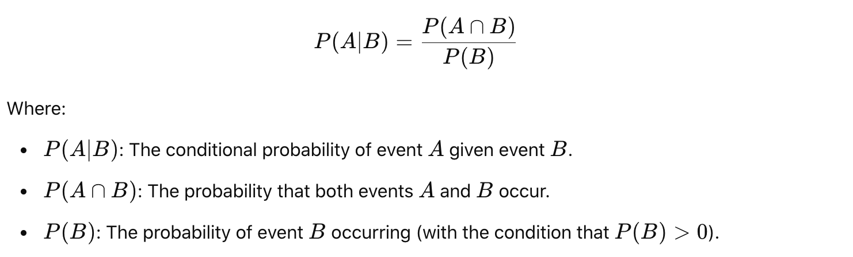

**Bayes Theorem**

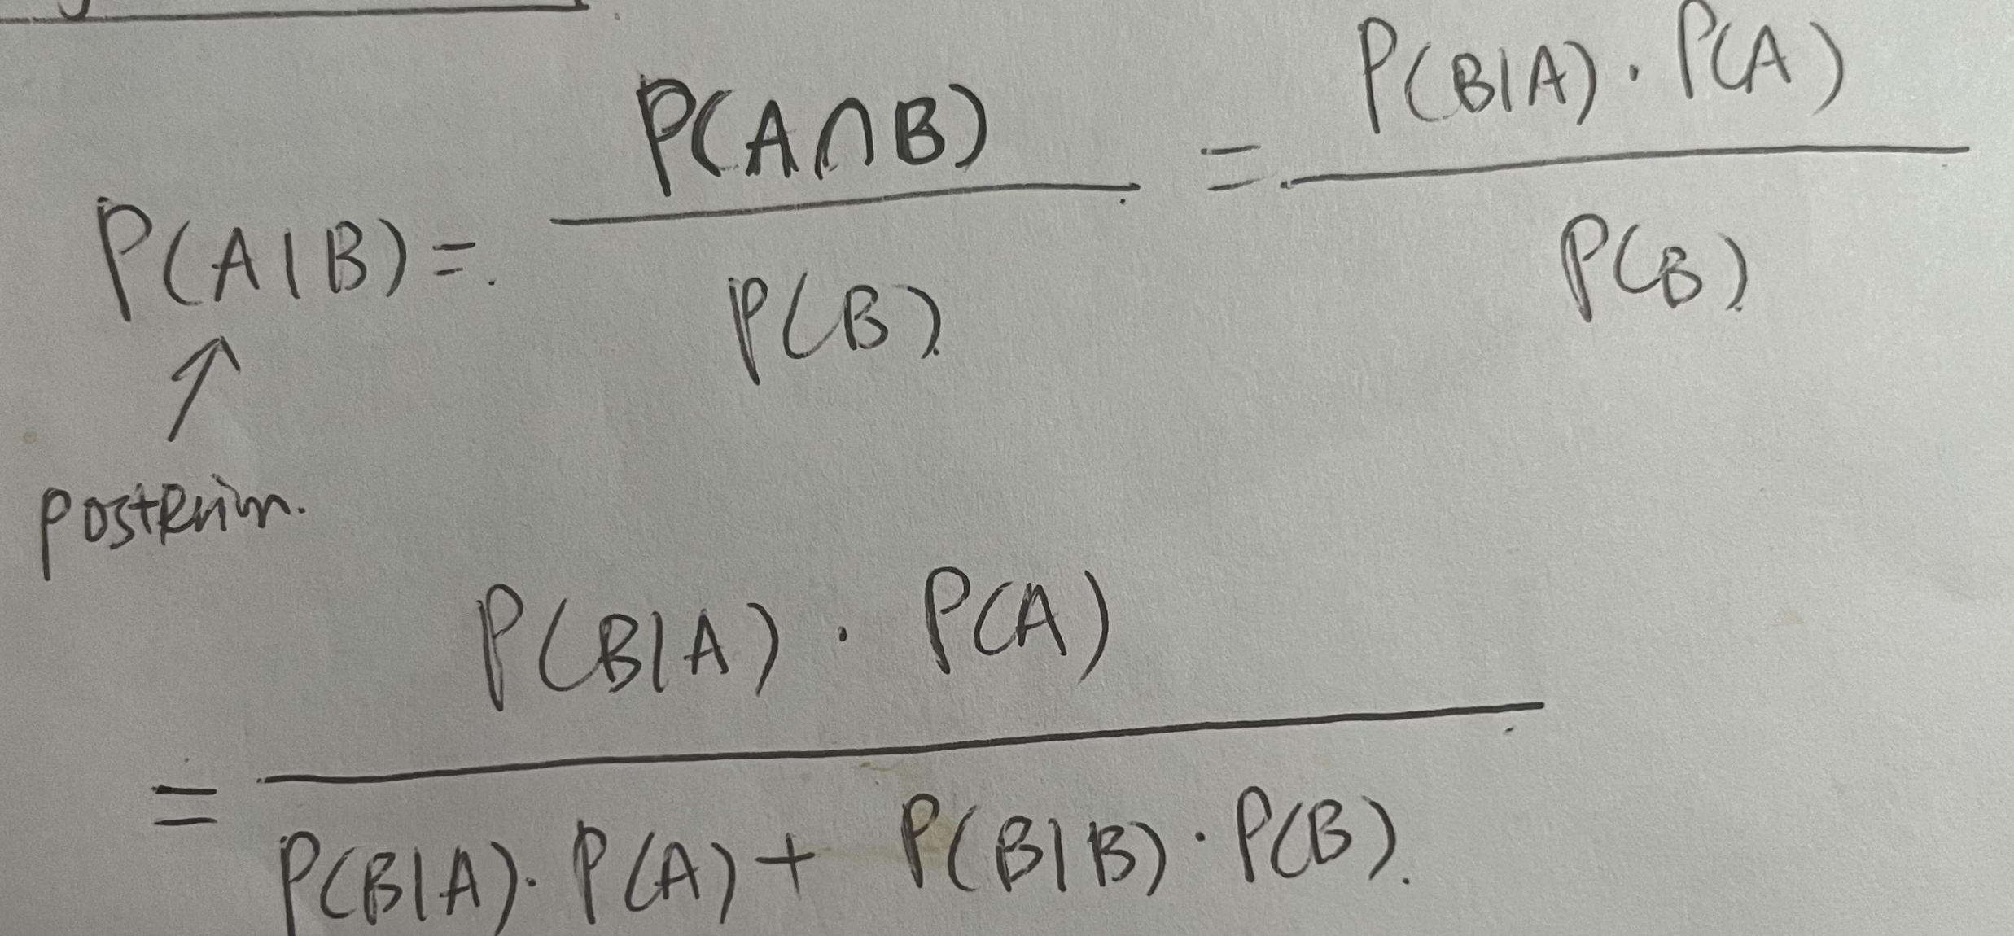

**Law of total probability**



**Expected value**

Average outcome of a random variable over many trials or experiments

**Permutation:** Arrangement of objects in a specific order.

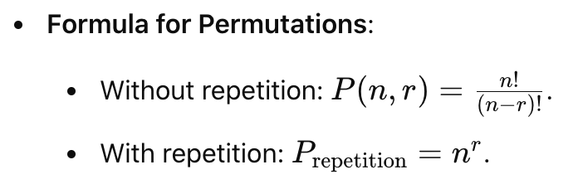

**Combination:** Selection of items from a larger set where the order of selection does not matter.

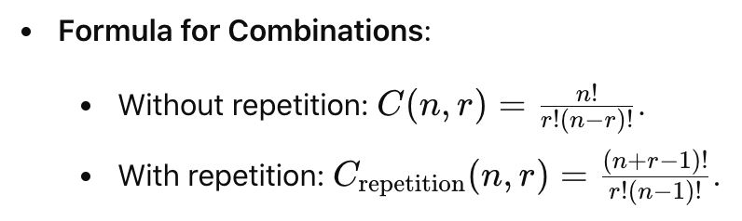

**Bernoulli distribution**

Discrete probability distribution: model the outcome of a single trial or experiment that has two possible outcomes.

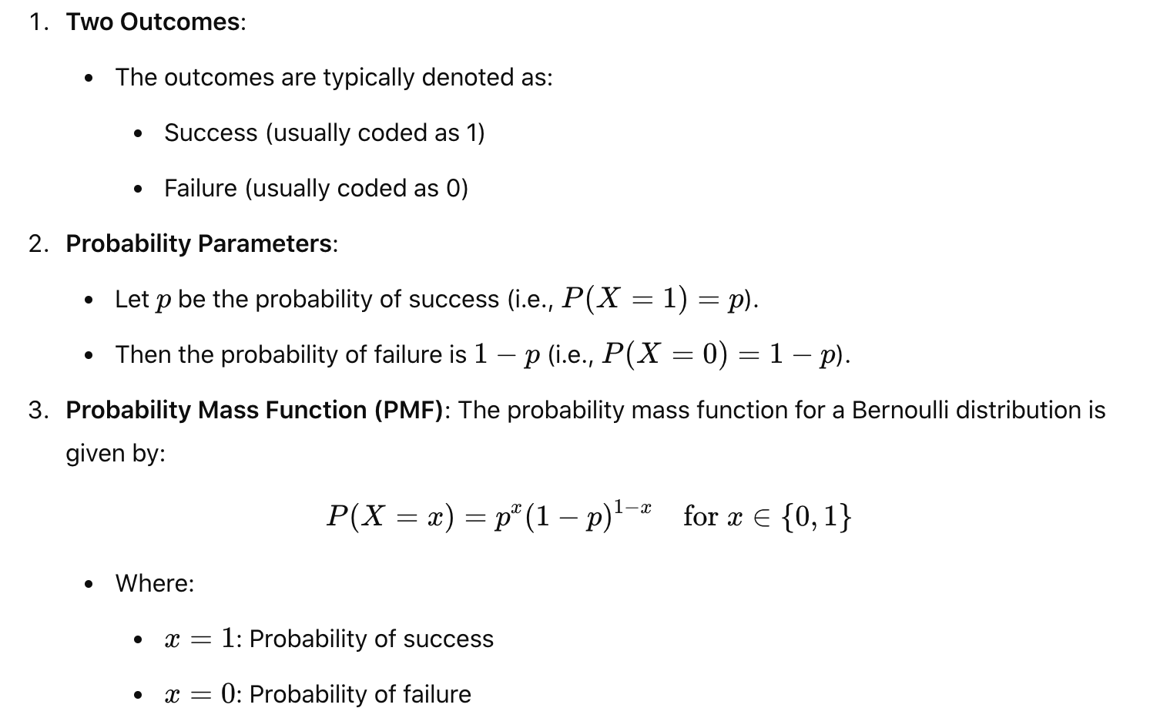

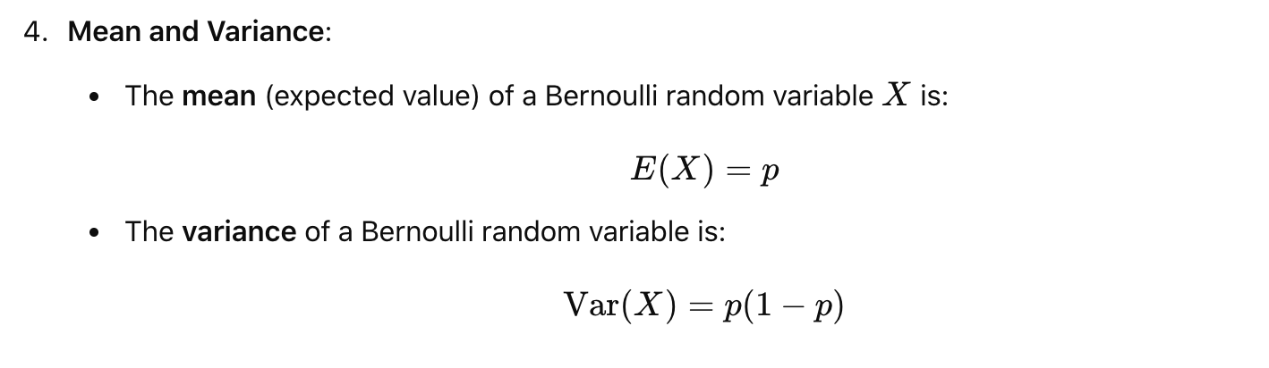

**Binomial distribution**

Discrete probability distribution; Trials are independent, which is achieved through replacement

The probability of observing exactly k successes in n trials with the probability of success on a single trial to be p

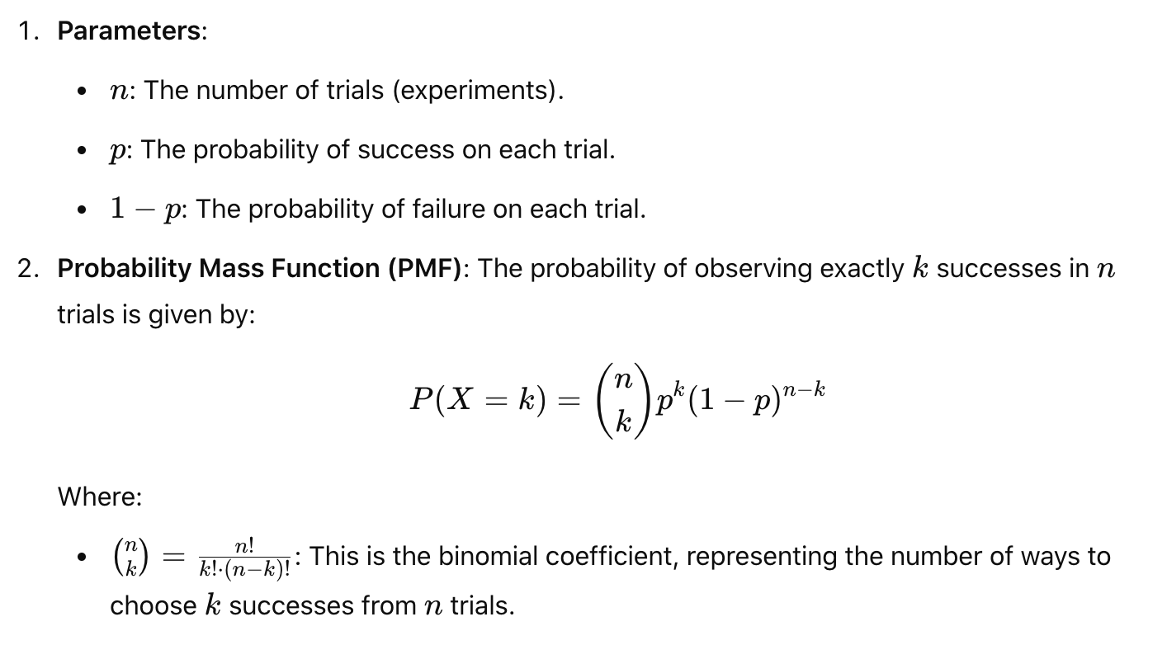

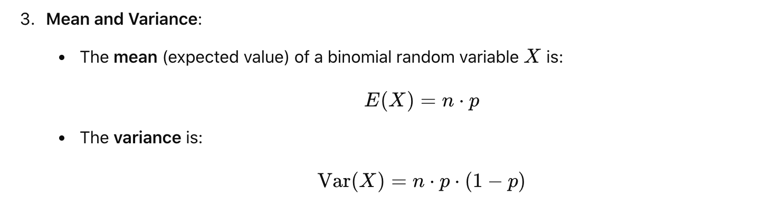

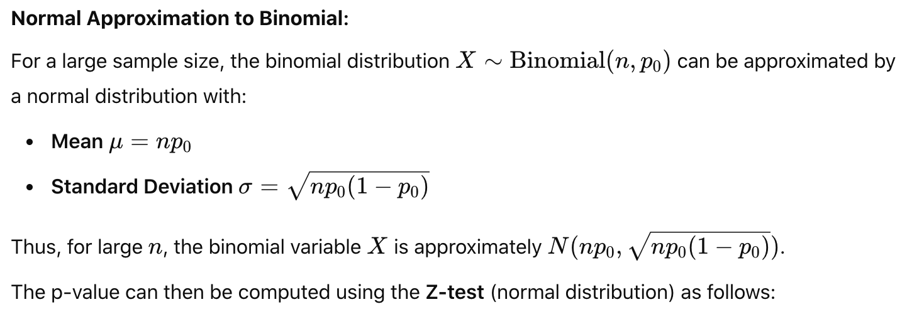

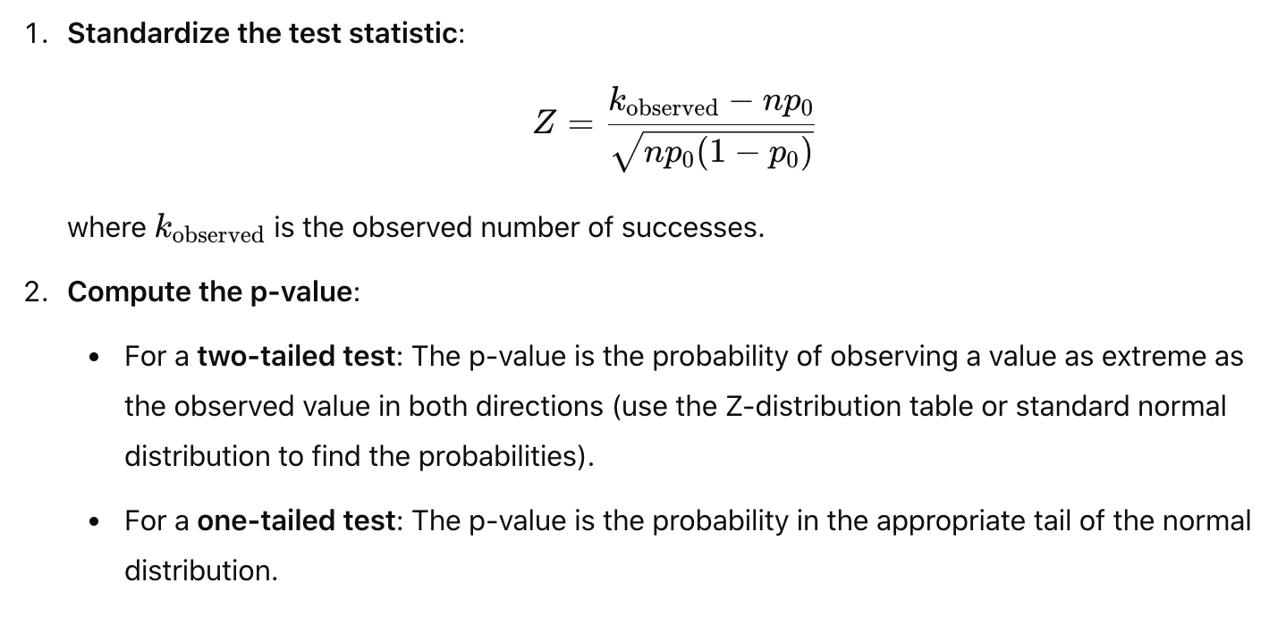

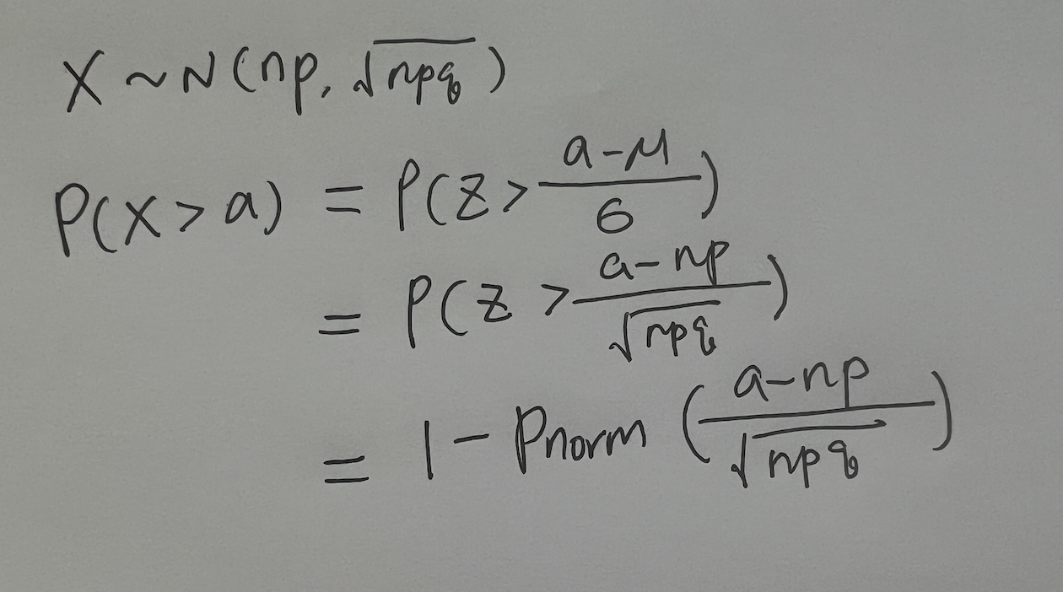

When the sample size (n) is very large, the binomial distribution can be approximated by a normal distribution due to the Central Limit Theorem (CLT). This is especially useful when computing p-values for large samples, as it simplifies the calculation.

**Normal distribution**

Continuous probability distribution that is symmetric around its mean

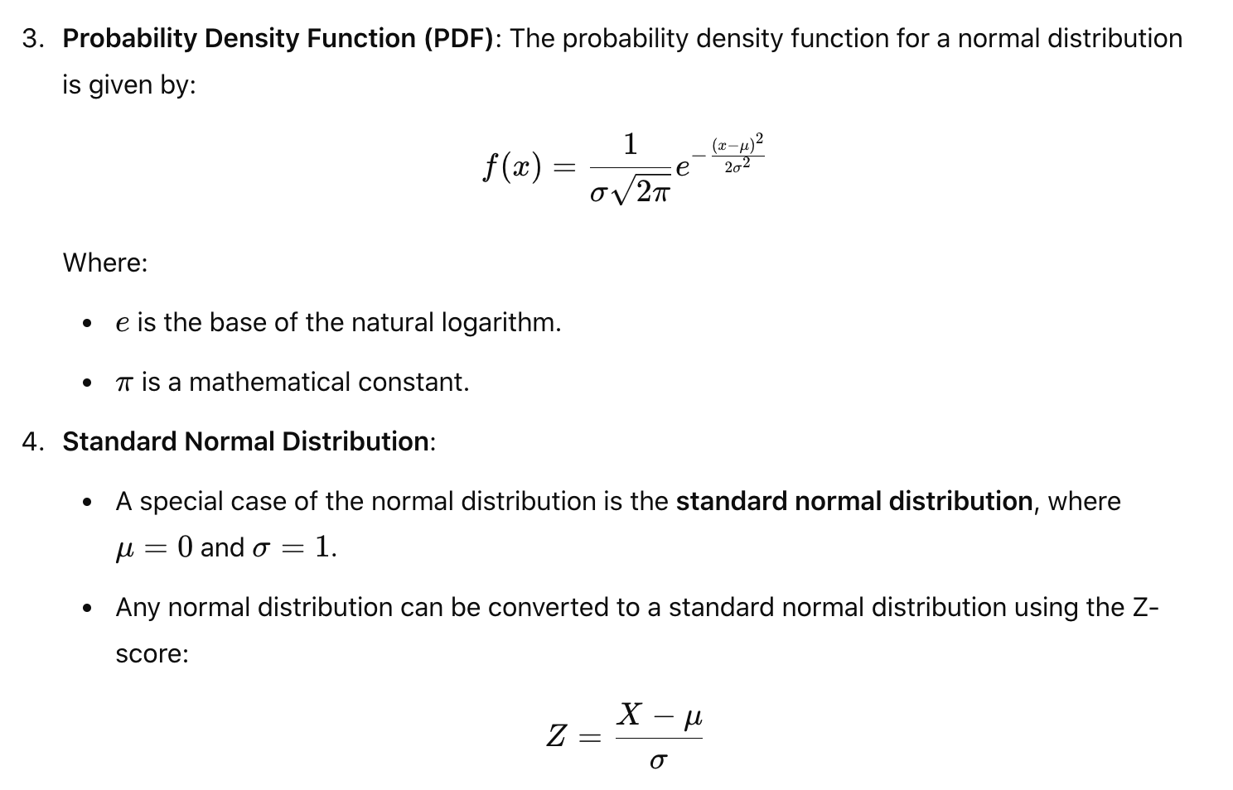

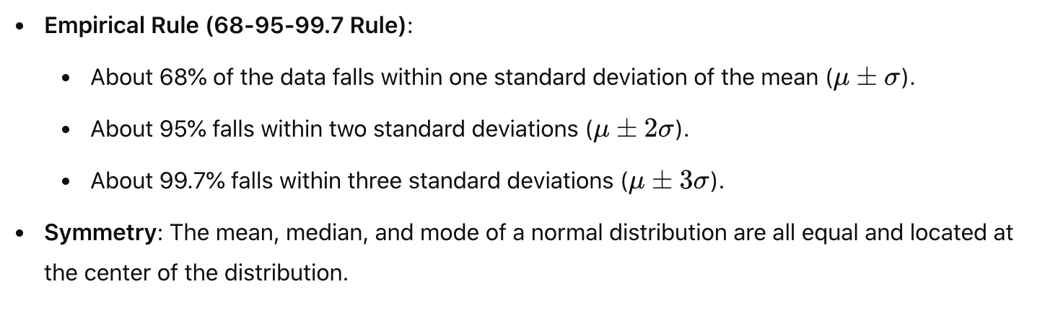

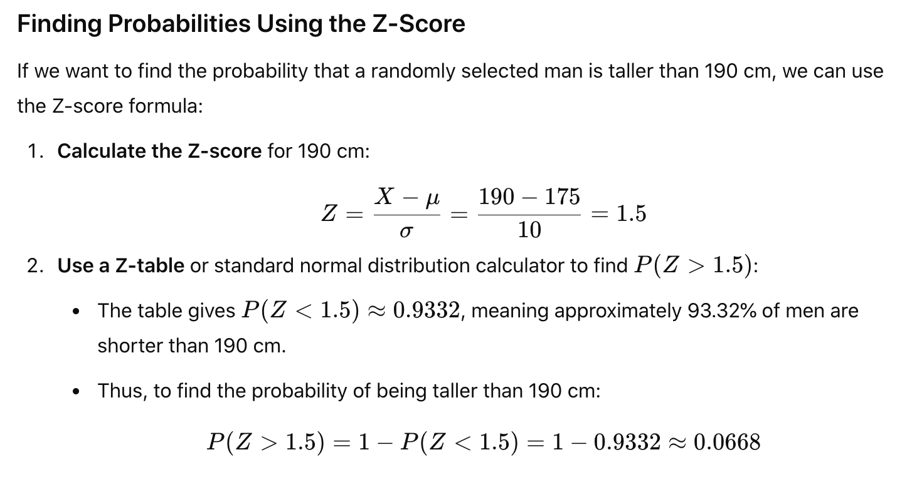

**Long tail distribution**

A **long-tail distribution** is a type of probability distribution that has a large number of occurrences far from the "head" (or peak) of the distribution.

**Law of large numbers**: As number of trials increase, the sample mean will converge to population average / expected value.

**Central limit theorem**: Distribution of sample means approaches normal distribution as sample size increases. The distribution would be centered at population average.

* Population 🡪 Samples 🡪 Distribution 🡪 population mu: from population, we draw repeated samples, for each sample, we calculate sample mean, and draw the distribution of sample means, it will approach normal distribution as we draw more and more samples.

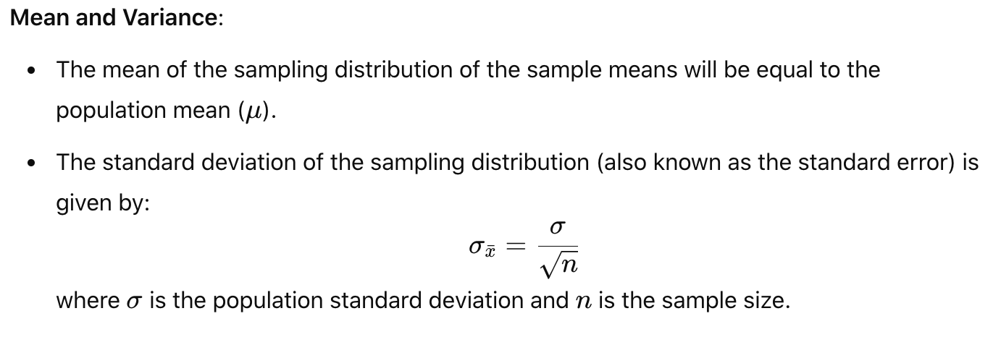

**Experimentation**

**Hypothesis testing**

* **State the hypotheses:**
  + **H₀: The average height is 170 cm (no difference).**
  + **H₁: The average height is not 170 cm (there is a difference).**
* **Choose α: Set α = 0.05 (5% significance level).**
* **Choose the test:** 
  + **Z-test: For large sample sizes or known population standard deviation.**
  + **T-test: For small sample sizes or unknown population standard deviation.**
  + **Chi-square test: For categorical data, testing independence or goodness-of-fit., or significant association between two categorical variables.**
* **Collect data: Randomly sample 50 individuals and record their heights.**
* **Calculate the test statistic: Compute the sample mean, standard deviation, and use the t-test formula to find the t-statistic.**
* **Determine the p-value: Calculate the p-value from the t-distribution.**
* **Make a decision: If the p-value is less than 0.05, reject H₀. If the p-value is greater than 0.05, fail to reject H₀.**
* **Draw a conclusion: If H₀ is rejected, conclude that the average height is significantly different from 170 cm. If H₀ is not rejected, conclude that there is no significant difference.**

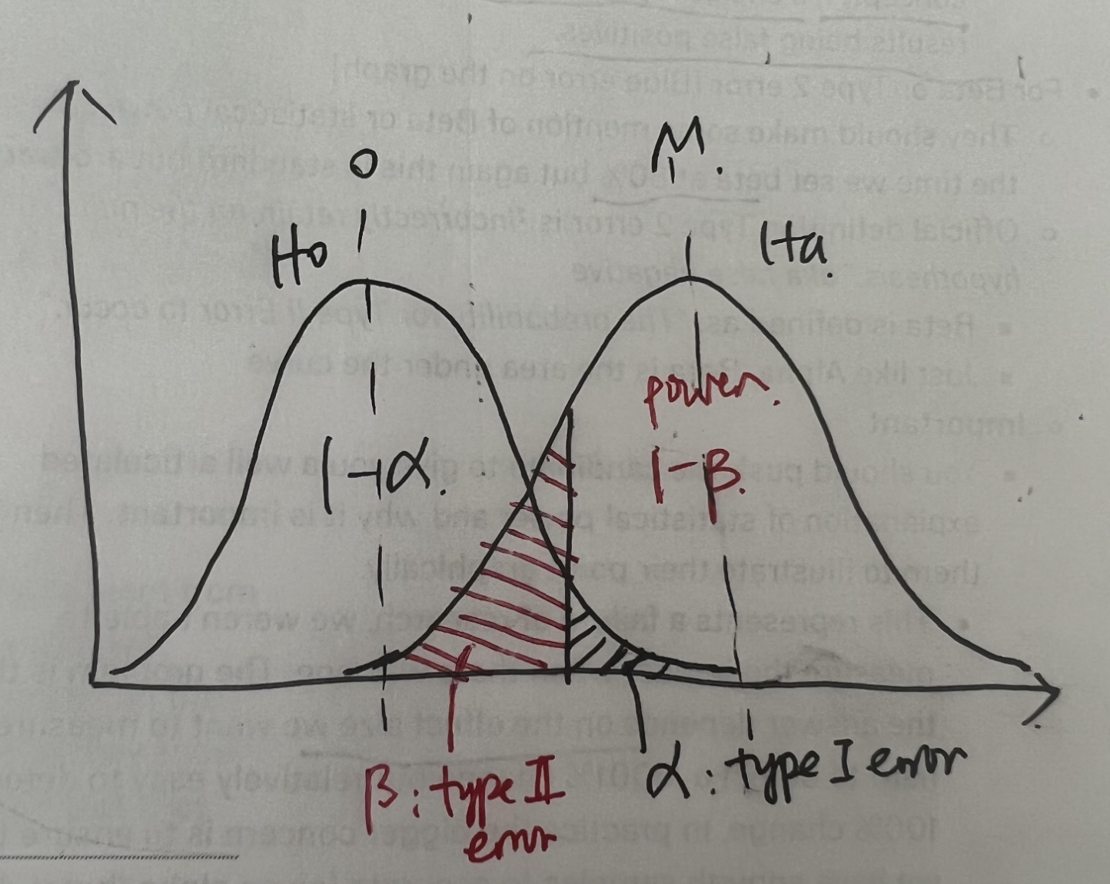

**p-value**:

* The probability of observing test results/statistic or something more extreme, assuming the null hypothesis is true.
* The p-value tells you how likely it is / the probability that the results you’re seeing could happen just by chance, assuming there is no effect.
* Low p value 🡪 less support of null hypothesis, stronger evidence against null hypothesis, and more convinced of the difference of the two groups.
* P value < alpha: 0.05, then reject null hypothesis; p value > alpha: 0.05, then fail to reject null hypothesis

**Type I error (false positive / significance level / alpha** α**):**

* The probability of rejecting null hypothesis when it is actually true
* We conclude findings are significant but in fact they occurred by chance / there is no real difference

**Type II error** β **(false negative):**

* Fail to reject null hypothesis when the alternative hypothesis is true
* We conclude there is no significant effect or difference but in fact there is one

**Power (1- type II error)**:

* Probability correctly rejects the null hypothesis when alternative hypothesis is true
* Likelihood that a test will detect an effect when the effect is present
* You want enough power in your experiment to be able to conclude with high probability whether your experiment has resulted in a change bigger than what you care about.

**Sample size:**

If the sample size is fixed, then decreasing α will increase β. If we want both α and β to decrease (i.e., decreasing the likelihood of both Type I and Type II errors), then we should increase the sample size.

Small samples 🡪 variance large 🡪 curve flatten 🡪 less power

Large samples 🡪 variance small 🡪 curve narrow 🡪 more power

* Large samples 🡪 variance small 🡪 t-statistic (z-score) larger and p-value smaller 🡪 more power to reject null

**Experimentation process**

<https://medium.com/jonathans-musings/ab-testing-101-5576de6466b>

**How would you decide whether to launch this feature and measure impact?**

Hypothesis, metrics 🡪 randomization, trigger point 🡪 power analysis to determine sample size 🡪 launch test 🡪 data validation i.e. smoke test 1 day post launch 🡪 early results to check for large decrease in key metrics 🡪 run test for time duration and conduct analysis when we reach runtime

1. Hypothesis & goal?
2. Metrics? Primary, secondary and guardrail metrics. Set GA criteria
   1. Sum and count: volume
   2. Ratio: click through rate, conversion rate
   3. Distributional metrics: mean, medium, 25%, 75%, 90% percentile
      1. Mean is sensitive to outliers but not robust
      2. Median is robust but it may not change at all
3. Experiment design?
   1. Randomization unit:
      1. user id (concerns due to network effect)
      2. session id (include logged out users): group of webpages viewed on a single visit
         1. For landing page and signup experiment, we randomize on session id
         2. cookie id: when a user visits, website writes a cookie containing an identifier; can be erased or incognito browse session used, leading to undercounting or overcounting
      3. device id (include logged out users and mobile only)
      4. cluster based: time block, time region block (address network effect)
   2. Target audience: eligible users; who will be exposed to the experiment? Align with randomization unit; specific population vs all users
   3. Trigger point / unit of diversion: to be close to product experience change. Otherwise variants will dilute too much, baseline and variant value will be very close, because the majority of the users are not converting, so harder to detect a stats sig change.
   4. Test group: # variants, test design
4. Event logging with eng: log events on key CTAs (client side & server-side logging)
5. Runtime:

**Power analysis**: determine the smallest sample size required to detect the effect of a given test at the desired level of significance. We want to run the power analysis to make sure we get enough power to justify the investment into the test.

* 1. Statistical parameter:
     1. MDE: expected lift, effective size
     2. Significance level (alpha): probability of incorrectly flagging a stats sig change (0.05)
     3. Power (1-beta): probability of correctly flagging a real stats sig change
     4. Baseline conversion rate for proportion test, Baseline standard deviation for mean test

Sample size required for each group in two-sample proportion test:

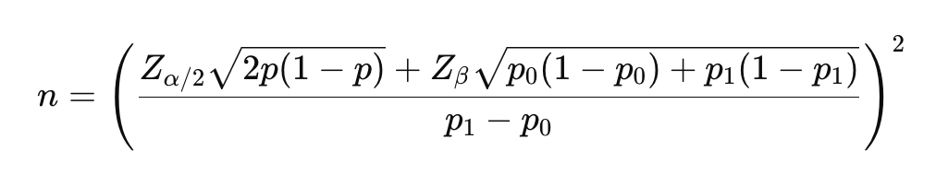

Sample size required for each group in two-sample mean test:

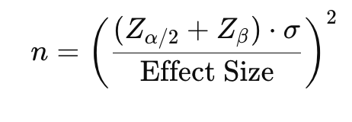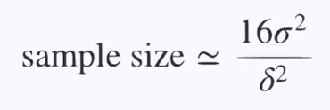

Total required sample size = required sample size * # variants

Runtime = Total required sample size / daily traffic

* 1. Non statistical parameter: seasonality, other test, product rollouts, full business cycle, countries, subpopulation

How to run test faster? Reduce sample size?

* + Increase significance level alpha
  + Reduce power (1-beta)
  + Increase MDE
  + Increase traffic: fewer variants; add trigger point more up the funnel to increase traffic (caveat on dilution)
  + Prefer to choose a metrics with a relatively larger absolute baseline proportion value / rate
  + Lower variance:
    - Ratio metrics have smaller standard error than mean metrics, meaning we will not need to expose the experiment to as many users to achieve the same sensitivity
    - Transform a metric through capping, binarization or log transformation. Heavy long-tailed metrics, consider log transformation; binary metrics to indicate whether user streamed more than x hours in a time period
    - Stratification: divide the sampling into strata, sample within each stratum separately, then combine results from individual strata for the overall estimate, which usually has smaller variance than estimating without stratification (post stratification, which applies stratification during analysis).
    - Control-variates or CUPED: it uses covariates as regression variables. CUPED utilizes pre-experiment data.
    - Randomize at a more granular unit i.e. each page view. Disadvantages: bad user experience; not able to measure any user level impact over time
    - Paired experiment: if you can show the same user both treatment and control in a paired design, you can remove between user variability and achieve a smaller variance
  + Sometimes we may decide to ship an experiment as long as there's no regression on primary metric + guardrails. We'd usually run experiments like this as a one-sided experiment.

How to increase power?

* + Increase sample size (Large samples 🡪 variance small 🡪 curve narrow 🡪 more power)
  + Decrease standard error
  + Increase the difference between sample statistic and hypothesized parameter or effect size

(When we increase the sample size, decrease the standard error, or increase the difference between the sample statistic and hypothesized parameter, the p value decreases, thus making it more likely that we reject the null hypothesis.)

* + Increase significance level (When we increase the alpha level, there is a larger range of p values for which we would reject the null hypothesis.)
  + Use a directional test as opposed to two tailed test (Going from a two-tailed to a one-tailed test cuts the p value in half.)

Note:

* + Small samples 🡪 variance large 🡪 curve flatten 🡪 less power
    - Small samples 🡪 variance big 🡪 t-statistic (z-score) smaller and p-value larger 🡪 less power to reject null or easier to reject 🡪 larger type I error and smaller type II error
  + Large samples 🡪 variance small 🡪 curve narrow 🡪 more power
    - Large samples 🡪 variance small 🡪 t-statistic (z-score) larger and p-value smaller 🡪 more power to reject null or more difficult to reject 🡪 smaller type I error and larger type II error

Underpowered test:

**Small sample size**

**Small effect size**

**High variance**

Why do you use ratio metrics instead of mean metrics as primary metrics?

* + Ratio metrics:
    - Account for differences in group sizes or variations in the data; Results are less sensitive to fluctuations and outliers
    - A more stable measure of performance because they focus on relative relationship between the two groups; Normalize the data
  + Mean metrics:
    - have higher variance, especially when data includes outliers or extreme values. High variance in mean metrics can make it more difficult to detect statistically significant differences, requiring a larger sample size.
    - Mean metrics could be misleading when groups differ significantly in size, as the mean can be disproportionately affected by the larger group.

Issues with randomizing on session id?

* Cross-Session Contamination (Same User in Multiple Groups)
  + Since users can have multiple sessions, they might be assigned to different experiment groups across sessions.
  + Problem: The user experiences both conditions, making it hard to isolate the experiment’s true effect.
* Inflated Sample Size (Pseudoreplication)
  + A single user may generate multiple session IDs, leading to an overestimation of the number of independent observations.
  + Problem: The experiment may appear to have a large sample, but many sessions belong to the same users, violating the assumption of independence in statistical tests.
* Bias Toward High-Frequency Users
  + Users who have more sessions are overrepresented in the experiment.
  + Problem: Results become skewed toward behaviors of frequent users, not representing the overall user base.

How to choose MDE?

* Check past experiments and use historical lift
* Assess whether the change is meaningful and valuable
* Show sensitivity analysis with a range on MDE and corresponding runtime for reference
  + If sample size is too large 🡪 increase MDE
  + If MDE is too high 🡪 test a more significant change
* Consider sequential test

1. Ramp up plan and launch test
2. Smoke test: control vs. treatment balanced?
3. Analysis: metrics stats sig (calculate p-value) and confidence interval
   1. Ratio metrics: two sample proportion z-test or chi-square test (Underlying population follows binomial distribution, which can be approximated by normal distribution when n is large; known population standard deviation)

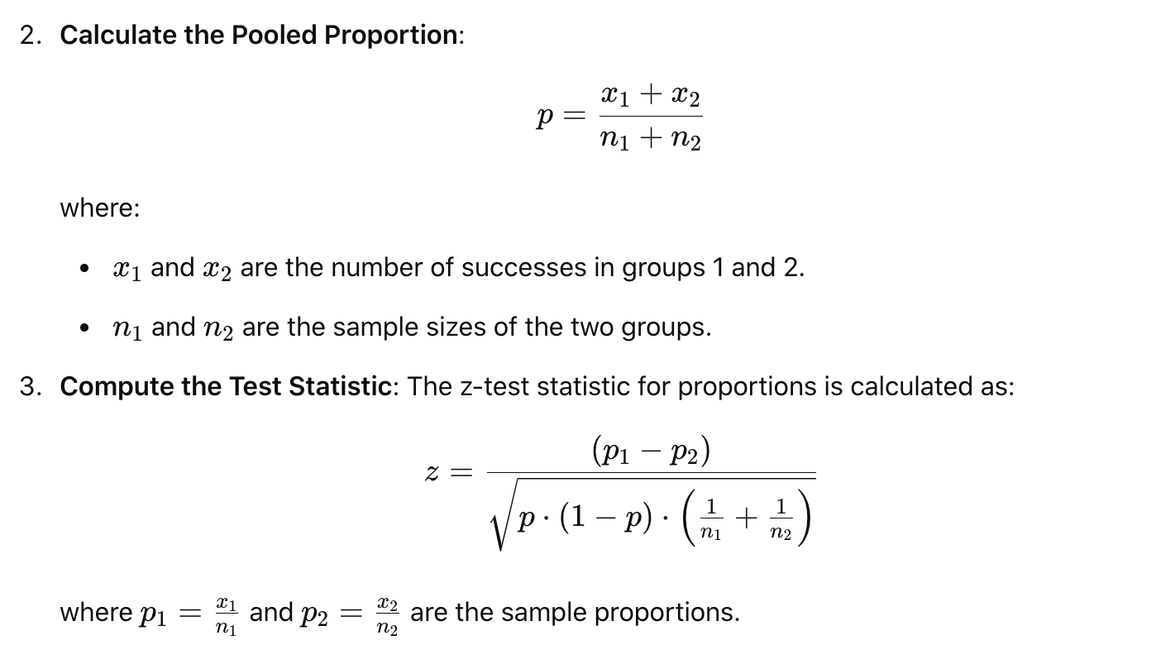

Confidence interval:

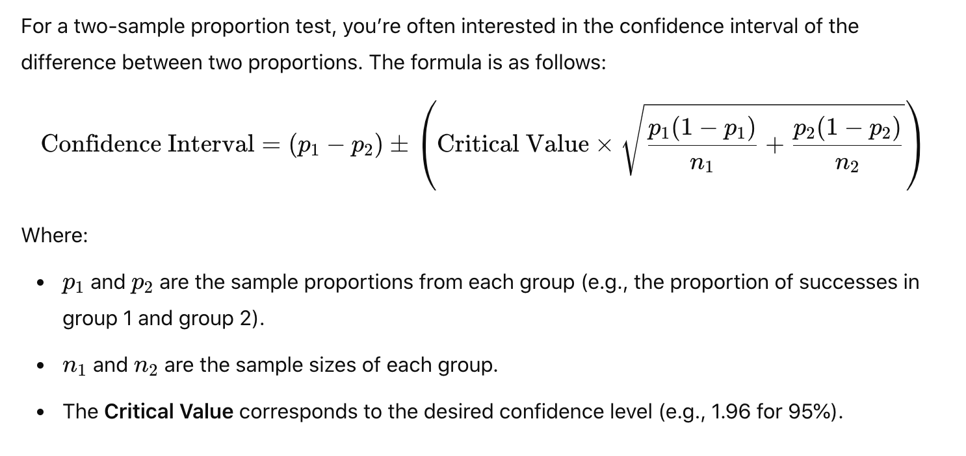

* 1. Mean metrics: two sample mean t-test

Test statistics follow a Student’s t distribution (Underlying population are normally distributed; population standard deviation is unknown)

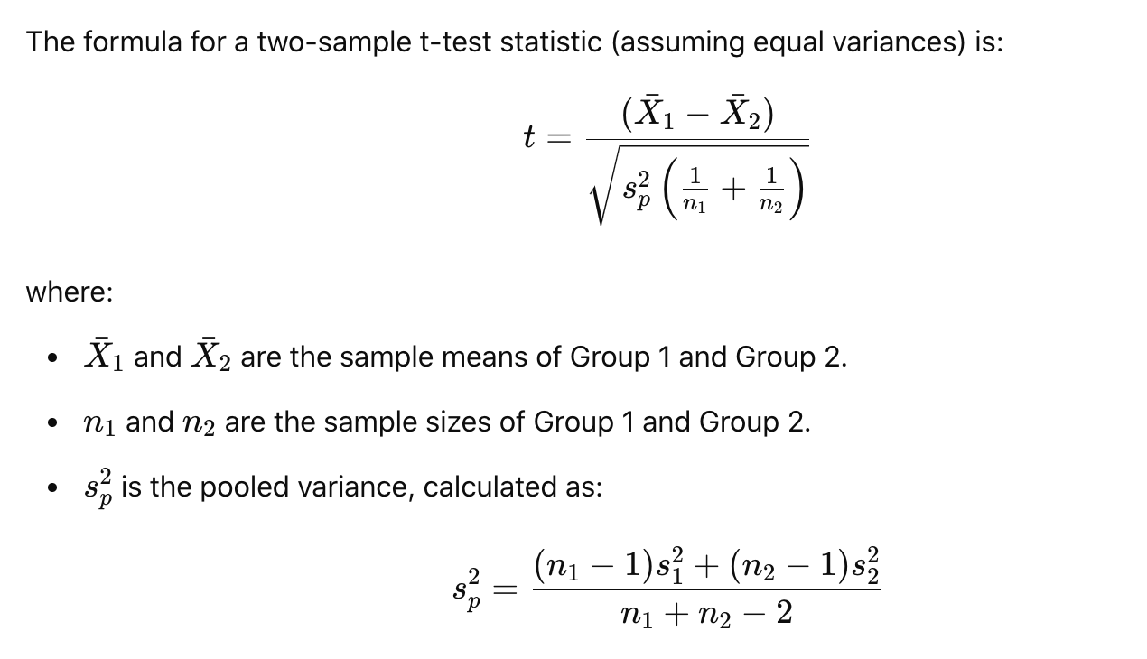

Confidence interval:

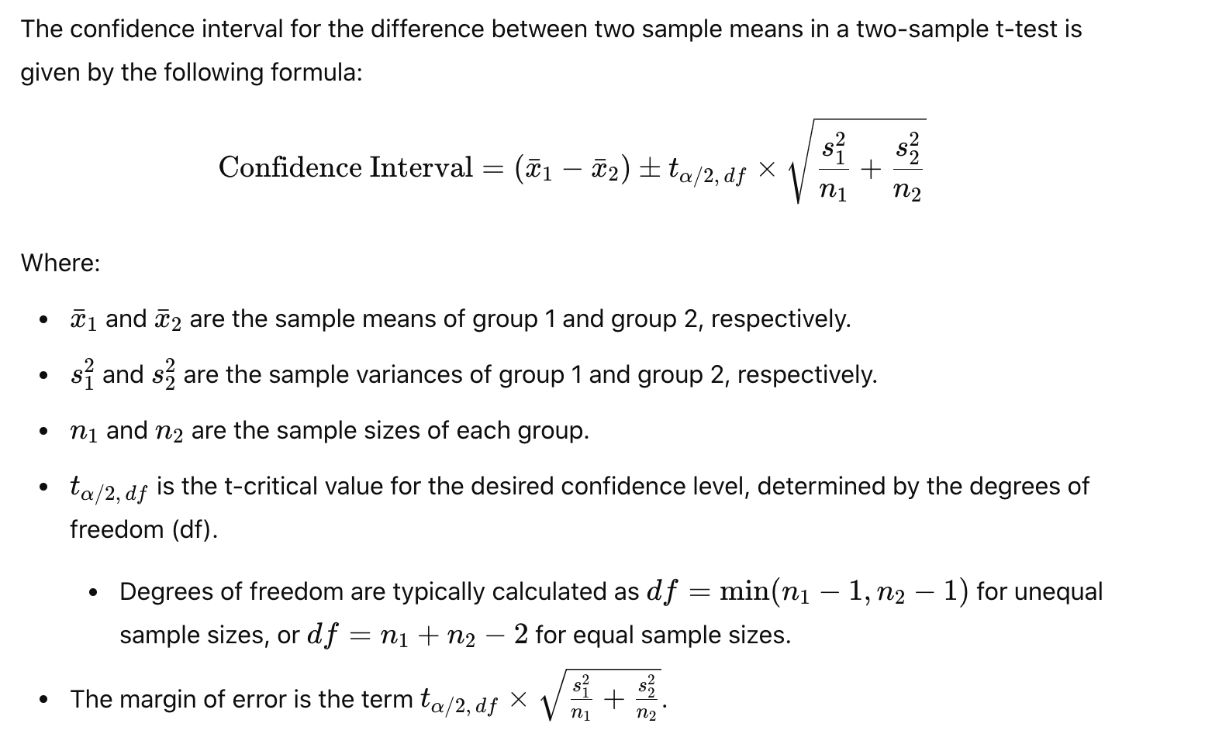

1. Make recommendations:
   1. If meet GA criteria, then GA
   2. If not meet GA criteria with mixed results:

* Cost of launching a change: only launch when it is practically significant
  + Engineering maintenance, opportunity cost
  + If cost is high, benefit should outweigh the cost and set practical significance boundary
  + If cost is low, launch any change that is positive as long as results are statistically significant
* Deep dive on metrics to see why it is not performing well
  + Decompose the metrics
  + Find opportunities to optimize the experience and test another iteration
* Segmentation: Further slice and dice to locate segmentation with good performance; if result for certain cohort is good, then launch to that cohort
  + iOS vs. Android: different performance, can show different designs as user base is different
* Trade-off between metrics:
  + Calculate the net impact: creating an impact table and translate metric change into downstream metric (revenue or supply unit) impact and see what the net impact is. For example, if primary metric is % user sharing is up but recipient / sharer is slightly down, then we look at usually revenue metrics i.e. GNARR impact.
  + Set threshold for max loss/risk on certain metric: If goaling metric is very positive, then estimate total loss in other key or guardrail metrics and see whether this is within tolerance.
  + Short term vs. long term trade off: trade short term (revenue) loss for long term retention gain, which drives long term monetization gain
  + Global holdout to monitor trends; check the over time performance for first week cohort
* Product decision ultimately: If leadership is okay with the impact, then proceed with launch. (This is after carefully assessing that experiment is strategically important to move forward and there are no biases.)

1. Post launch monitoring:
   1. long term effect vs short term effect
   2. novelty effect

**Risks and limitation:**

1. Cannibalization: into other features, cannibalize advertising
2. Revenue trade off:
   1. Trade short term revenue loss for long term retention gain, which drives long term monetization gain
   2. More ads means short term revenue gain but ads fatigue and user experience may cause user churn and leads to long term revenue loss
3. Data maturity: TPCR (daily plot), conversion rate, churn rate takes longer time to mature
4. Seasonality effect: User behaviors change in holiday seasons.
   1. Global holdout group to measure real effect
   2. Calculating runtime, I can scale the traffic depending on seasonality. For example, to run a test in Dec, instead of using Nov traffic directly, but scale Nov data in the same ratio as last year Nov/last year Dec
5. Novelty effect:
   1. People welcome new changes and use more initially, but effects will not last long; Control vs. treatment: daily plot over time to see effect decreases
   2. Can run test on new users only; however, new users might not be representative of average tenured users
   3. If test is already running, compare first time users to old users in treatment group
   4. Global holdout and measure impact over time to see if effect is diluted
6. Network effect:
   1. We usually split users randomly to make sure users are independent
   2. Spillover effect / network effect:
      1. Social network: User behavior in social network is likely impacted by other people in their social circles. A user tends to use a feature or product more often if their friends use it. Treatment effect in treatment group may spill over to control group. The difference would underestimate true effect (actual effect > treatment effect)
      2. Two-sided marketplace: Resources are shared among control and treatment group, meaning control and treatment groups will compete for the same resources. If we have a new product / pricing incentives that attracts more drivers to the treatment group, then fewer drivers will be available in the control group, the difference would overestimate the true effect (actual effect < treatment effect)
   3. Market-based or geo-based test
      1. Split by geolocations: Test the feature in specific geographic regions or markets to limit exposure and cross-interaction. This approach can help approximate the impact without directly affecting users outside the test group.
      2. We choose two locations with similar demographics where we make sure key metrics such as DAU, MAU, time spent and ads revenue are roughly similar across the two locations pre-test.
      3. Use Diff in Diff:
      * Find two countries with similar historical trends
      * Treatment and synthetic control: one country is set as synthetic control and one country set as treatment
      * Calculate diff = post – pre for each country
      * Compare the diff of two countries; the difference of diffs would be actual effect of treatment
      1. Used commonly in marketing as Geo lift test
      2. Test at country level: pick certain countries first to lower risk. Prefer Australia and New Zealand as they are good proxy of US (geographically isolated, decent population, English speaking country, similar culture/user behavior to US); Canada is too close to US; UK needs to comply to GDPR in Europe
      3. Limitations: test performed in specific locations, which may not fully represent the larger population. Results may not generalize universally to all users; parallel trends assumption: the trend in outcomes for control units would be the same as the trend for treatment units; big variance in each group as markets are unique
   4. Cluster based randomization:
      1. Instead of randomizing at the individual level, this approach groups users into clusters (such as friend groups, geographic regions, or communities) and assigns the whole cluster to either the treatment or control group. By grouping users who are likely to interact, you minimize the spillover between the two groups.
      2. Per community random assignment: a common mathematical approach to defining user communities is to model the relationships between users with a [social graph](https://en.wikipedia.org/wiki/Social_graph), and then apply graph partitioning algorithms to find isolated, non-interacting groups.
      3. Limitations: Difficult to detect stats sig result as cluster-based randomization is usually under powered. We have smaller sample size and bigger variance for the cluster-based test.
   5. Ego-network randomization: https://arxiv.org/pdf/1903.08755
      1. A cluster is composed of an ego (focal individual) and her alters (individuals she’s immediately connected to)
      2. One-out network effect: the effect of my immediate connections treatment on me. Instead of giving it to you, they only give it to your direct connections (your "alters"), and see how does this change my behavior; Users either has a feature or doesn’t
   6. Switchback test:
      1. Randomize spatial units ranging from city or region blocks to time intervals
      2. In switchback testing, the core concept is that we switch back and forth between control and treatment algorithms in a certain region at alternating time periods. For example, in the SOS pricing example, we switch back and forth every 30 minutes between having SOS pricing and not having SOS pricing. We then compare the customer experience and marketplace efficiency between the control time bucket and treatment time bucket metrics
      3. The coarser these experimental units, the stronger the protection against interference bias in your effect estimates.
      4. However, the cost is increased variance and smaller sample size in your estimators, which would cause test to be lower in power; violate independence: sandwich estimator of variance

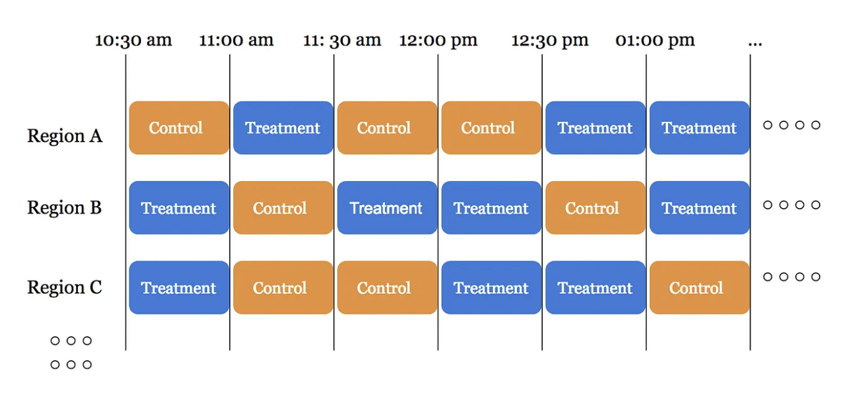

* + 1. Alternating time intervals between global control and global treatment was a successful strategy for Lyft: Alternating time interval experiments perform well if the effect size is very large or we just happen to get lucky with temporal fluctuations
    2. How to decide on granularity: 30min time block at city level:
    - Don’t want time region units that are too small 🡪 risk introducing bias (more short rides)
    - Don’t want time region units that are too large 🡪 risk having large margin of error (variance) and sample size small to run test for long
    1. This means we’re conducting our statistical tests on the average valuesof control and treatment time-region units**,** rather than the individual values of control and treatment deliveries.

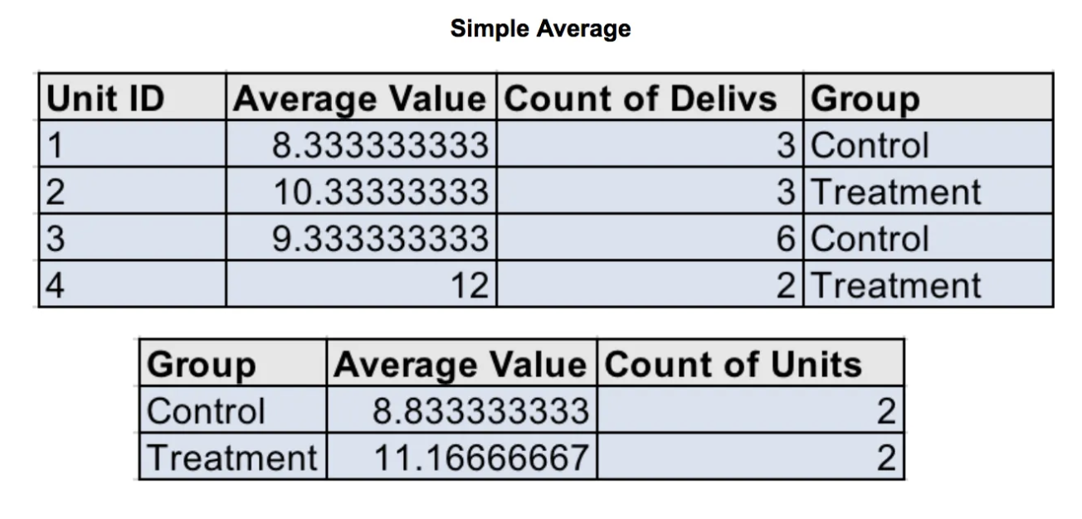

1. Limitation: it works when treatment effect only lasts for a short amount of time for example if a new surge price algorithm works better; it does not work when treatment takes long time to be effective i.e. referral program.

Some resources on network effect:

[How Meta tests products with strong network effects](https://medium.com/@AnalyticsAtMeta/how-meta-tests-products-with-strong-network-effects-96003a056c2c#id_token=eyJhbGciOiJSUzI1NiIsImtpZCI6IjczZTI1Zjk3ODkxMTljNzg3NWQ1ODA4N2E3OGFjMjNmNWVmMmVkYTMiLCJ0eXAiOiJKV1QifQ..XXAQIO6wu0kJh63j3R1TGZ0uOUXzIdAmDrikG7686g1gM_DteIQkKIkp5DJATAeIZSarh0vrkrrC2KrBN9nLSJ54vadPcOIXT_VWM_BS119sKHX04SFO2Luda6Hdz3_0wc06QJqK2f2FU8IN44LJxTcZnv5AcvsrsFrNkU7GhvkysBNfJWD0PmbkR4fzaOY_6bfI4BCERPjoNRXLfkMhV9XijbHaAPK_TqNg7wxMcSSO73F72IWSdgGXJs0nftCM7nJc8lSSZdKaILWyrKvE8TOZZxmBCoXPN5Zi4e6hCn38CXuMUMb7tXZu0xjYAGGoO0mc1I7iov9nvbGNeoQAuA)

[Why spillover effects bias your AB testing results and ways to overcome them](https://medium.com/@weonhyeok.chung/why-spillover-effects-bias-your-ab-testing-and-ways-to-overcome-them-e7f06efd0b56)?

[The pitfalls of A/B testing in social networks](https://tech.okcupid.com/the-pitfalls-of-a-b-testing-in-social-networks-17d631d7b20d)

[Challenges in experimentation](https://eng.lyft.com/challenges-in-experimentation-be9ab98a7ef4)

[Experimentation in a ridesharing marketplace](https://eng.lyft.com/experimentation-in-a-ridesharing-marketplace-b39db027a66e)

[Balancing network effect, learning effects and power in experiments](https://careersatdoordash.com/blog/balancing-network-effects-learning-effects-and-power-in-experiments/)

[Experiment rigor for switchback experiment analysis](https://careersatdoordash.com/blog/experiment-rigor-for-switchback-experiment-analysis/)

[Switchback tests and randomized experimentation under network effects at Doordash](https://careersatdoordash.com/blog/switchback-tests-and-randomized-experimentation-under-network-effects-at-doordash/)

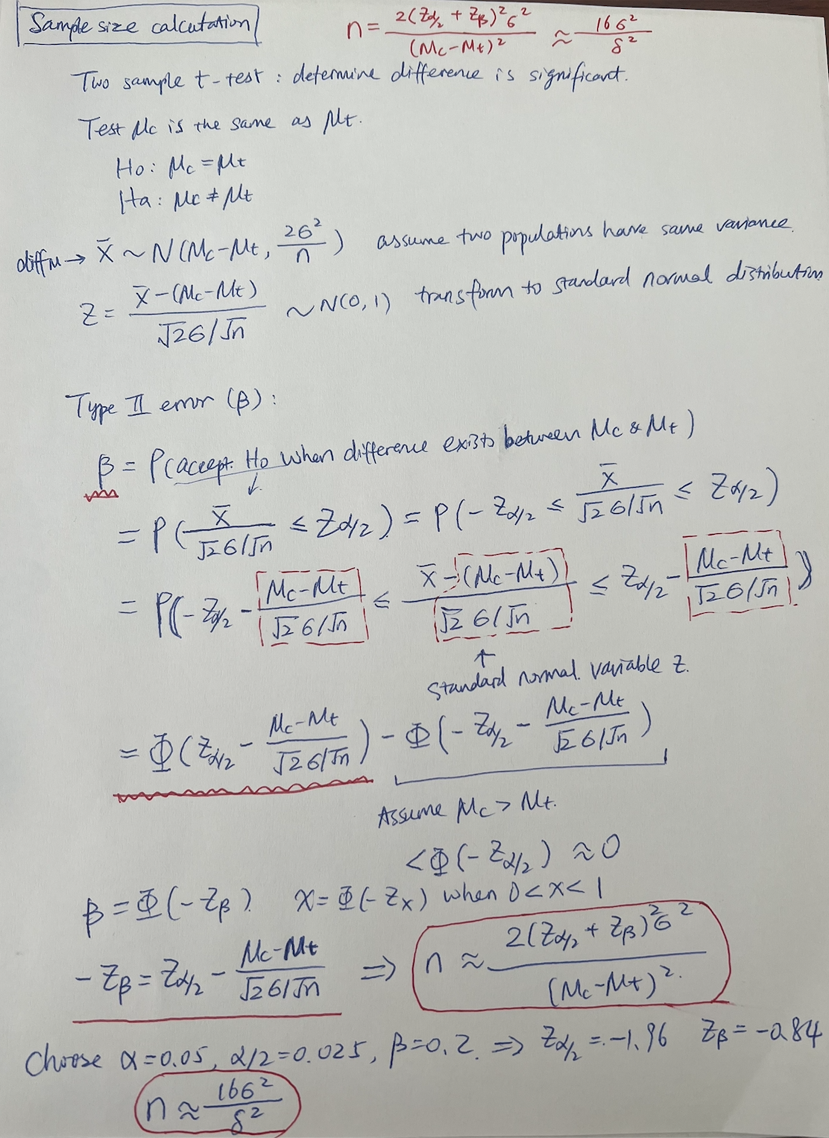

**Confidence interval**

It provides an interval within which we expect the true population parameter to lie, with a certain level of confidence.

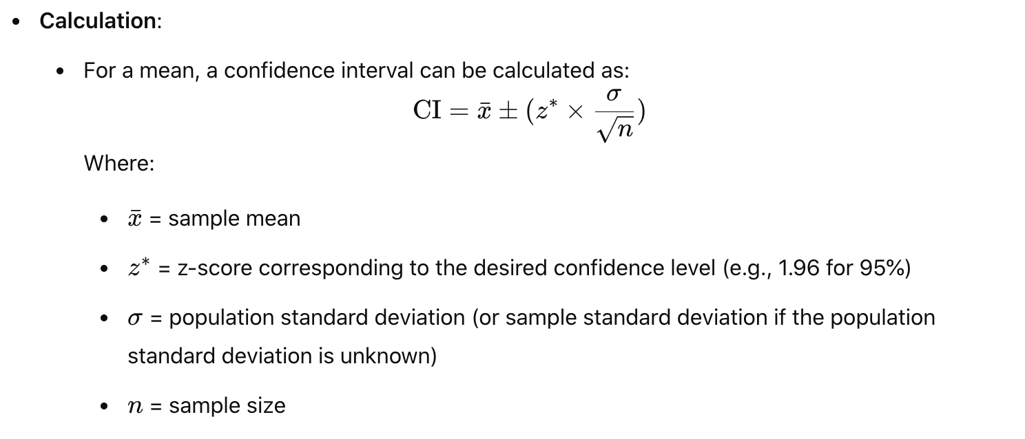

If you have a 95% confidence interval of (10, 20), it means you can be 95% confident that the true population mean falls within this range. For example, a 95% confidence interval means that if you took many samples and calculated a confidence interval for each one, 95% of those intervals would contain the true average value (the actual average for everyone, not just your sample).

Steps:

* Take a Sample
* Find the Average of Your Sample
* Understand the Spread: Variation – standard deviation
* Pick a Confidence Level
* Calculate the Margin of Error:
  + How much variation there is in your data (the standard deviation).
  + How many people you sampled (larger samples tend to give more accurate results).
  + The level of confidence (the higher the confidence, the wider the range).
* Calculate the Confidence Interval: add and subtract the margin of error from your sample's average to get the range.

**Peeking:**

* In A/B testing, "peeking" might refer to the tendency to check interim results too frequently, which can lead to premature conclusions about the test outcomes. This behavior can introduce bias and inflate the risk of false positives. Peeking results in higher chance of type I error.
* Peeking sometimes help us discover tracking issues; peaking only to fix issues / bugs (it’s okay to pause till bug investigation is over)
* Set a Predefined Analysis Plan: determine evaluation criteria – pick few key metrics, calculate time to power for each metrics, limit interim checks
* More advanced methods:
  + Sequential testing:
    - Sample size is not fixed in advance; a framework that does not require predetermined runtime / fixed sample sizes
    - Sequential confidence intervals: confidence intervals that hold to a certain confidence level over all of time. They solve the “peeking problem” so you can look at your results as often as you want knowing that your significance level holds. Sequential confidence intervals are wider than their fixed sample counterparts, so it’s harder for metrics to reach statistical significance when using sequential confidence intervals.
  + Multi-armed Bandits Approach
  + Bayesian methods
* Adjust for Multiple Comparisons: If you must check results early, use methods that adjust for multiple comparisons, like the Bonferroni correction.

**Multiple comparison problem:**

* Measure multiple metrics/tests/variants at the same time: When multiple statistical tests are conducted, the likelihood of obtaining at least one false positive (Type I error) increases.
  + Example: we are running 10 tests at the same time with different landing page. 1 case won and the p-value < 0.05, should we make the change? No.
* **Bonferroni correction**:
  + Significancelevel / number of tests; lower the significance level for each test. Example: if you’re testing 10 metrics, you might use a significance level of 0.005 (5% / 10) instead of 0.05 for each test.
  + **Conservativeness**: The Bonferroni correction can be overly conservative, especially when the number of tests is large. This may lead to a higher risk of Type II errors (failing to detect a true effect). 🡪 loss of power
* **False Discovery Rate** (FDR):
  + FDR = # false positives / (# false positives + # true positives); Rate of type I errors during multiple testing;
  + FDR is the expected value of number of false positives divided by number of rejections; it measures out of all the rejections of the null hypothesis that is all the metrics that you declare to have a statistically significant difference, how many of them have a real difference as opposed to how many were false positives.
  + Example: If 200 metrics with FDR at 0.05, means at least 1 false positive in 200 metrics
  + Techniques like the **Benjamini-Hochberg procedure** control the expected proportion of false discoveries, offering a balance between identifying real effects and limiting false positives.
* **Familywise Error Rate** (FWER): probability of making one or more type I errors when performing multiple tests

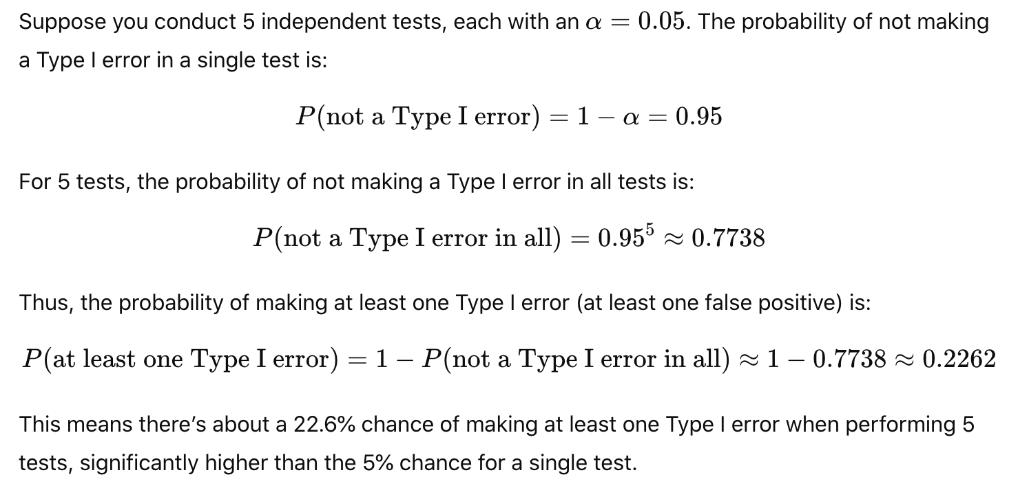

**Statistical significance vs. practical significance**

* For instance, if an A/B test shows a statistically significant increase in conversion rates, but the increase is only 0.1%, the practical significance may be questioned if that increase does not lead to a meaningful impact on revenue or user behavior.
* For large companies, 0.2% change could be practically significant; but for smaller companies, this is not

**Mitigating selection bias**

* **Selection bias refers to a type of error that occurs when the participants included in a study or analysis are not representative of the larger population intended to be analyzed**
* **Solution:**
  + **Random Sampling**: Use random methods to select participants to ensure a representative sample.
  + **Stratification**: Divide the population into subgroups and sample from each subgroup to ensure representation.
  + **Control for Confounding Variables**: Use statistical techniques to adjust for potential confounding factors.
  + **Longitudinal Studies**: Follow the same subjects over time to observe changes and reduce bias due to attrition.

**Stratification:**

Stratified sampling: process of dividing members of the population into homogeneous and mutually exclusive subgroups before sampling.

* Identify confounding variables: identify any potential confounding variables that could influence the overall relationship
* Stratify confounding variables: divide your data into homogeneous subgroups or strata based on confounding variables. We sample proportionally to the size of each strata.
* Testing within each stratum: perform the same statistical test within each stratum
* Compare adjusted results
* Recombine or aggregate carefully: weighted averages or other statistical methods (regression) when aggregating data

Issues with stratified sampling:

Post-test segmentation, however, will impact the statistical validity of your segments.  
1. The sample size of your segments is too small. Your test would be underpowered. You stopped the test when you reached the calculated sample size, but at a segment level the sample size is likely too small and the lift between segments has no statistical validity.  
2. The multiple comparison problem. The more segments you compare, the greater the likelihood that you’ll get a false positive (type I error) among those tests. With a 95% confidence level, you’re likely to get a false positive every 20 post-test segments you look at. You can correct this with Bonferroni correction to reduce the risk of false discoveries.

**Difference between t- test and z-test?**

<https://www.khanacademy.org/math/statistics-probability/significance-tests-one-sample/more-significance-testing-videos/v/z-statistics-vs-t-statistics>

The t-test and z-test are both statistical methods used to determine whether there is a significant difference between the means of two groups. However, they have different applications and assumptions. Here are the key differences:

1. Sample Size:

* t-Test: Generally used when the sample size is small (typically n < 30). It is more appropriate for smaller samples where the population standard deviation is unknown.
* z-Test: Used when the sample size is large (n ≥ 30). It assumes that the population standard deviation is known or that the sample size is large enough for the sample standard deviation to be a good estimate of the population standard deviation.

**2.** Distribution**:**

* t-Test: Based on the t-distribution, which has heavier tails than the normal distribution. This accounts for the added variability in smaller samples.
* z-Test: Based on the standard normal distribution (z-distribution). It assumes that the data are normally distributed.

**3.** Standard Deviation**:**

* t-Test: Uses the sample standard deviation (s) to estimate the population standard deviation (σ).
* z-Test: Uses the known population standard deviation (σ) when it is available. If σ is unknown and the sample size is large enough, the sample standard deviation can be used.

|  |  |  |  |  |
| --- | --- | --- | --- | --- |
| **Test type** | **Distribution** | **Sample size** | **Standard deviation** | **Example** |
| T-test | Student’s t-distribution: heavier tail than normal distribution | Small (n < 30) | Population standard deviation is unknown;  Use sample standard deviation | Two sample mean test:  Underlying population distribution follows a normal distribution |
| Z-test | Standard normal distribution: assume normal distribution | Large (n >= 30) | Population standard deviation is known;  If population SD is unknown, use sample SD if sample size is large | Two sample ratio test: Underlying population follows binomial distribution, which can be approximated by normal distribution when n is large |

**Assumptions of t-test**

A t-test is a statistical test used to compare the means of two groups and determine if they are significantly different from each other. The assumptions of a t-test are:

* Independence
  + The observations in each group should be independent of each other.
  + If using a paired t-test, the differences between the paired observations should be independent.
* Normality
  + The data in each group should be approximately normally distributed, especially for small sample sizes (n < 30).
  + If the sample size is large, the Central Limit Theorem suggests normality is less of a concern.
  + The residuals and difference of pairs should follow normal distribution
* Homogeneity of Variance (for independent t-test only)
  + The variance (spread) of the two groups should be approximately equal.
  + This is particularly important for the independent (unpaired) t-test and can be checked using Levene’s test.
  + If this assumption is violated (i.e., if one group has much higher variability than the other), the test may produce misleading results, increasing the chances of Type I (false positive) or Type II (false negative) errors.

If these assumptions are violated:

* For normality, a non-parametric test like the Mann-Whitney U test (for independent samples) or Wilcoxon signed-rank test (for paired samples) can be used.
* For unequal variances, use Welch’s t-test, which does not assume equal variances.

**Paired t-test**

A paired t-test (also called a dependent t-test) is a statistical test used to compare the means of two related groups to determine whether there is a significant difference between them.

Use a paired t-test when:

* The same subjects are measured twice (e.g., before and after treatment).
* The observations are dependent, meaning they are naturally paired (e.g., left eye vs. right eye of the same person).
* The differences between pairs follow a normal distribution (for small samples, n<30n < 30n<30).

Instead of comparing raw values, a paired t-test calculates the difference between each pair of observations and tests whether the mean difference is significantly different from zero.

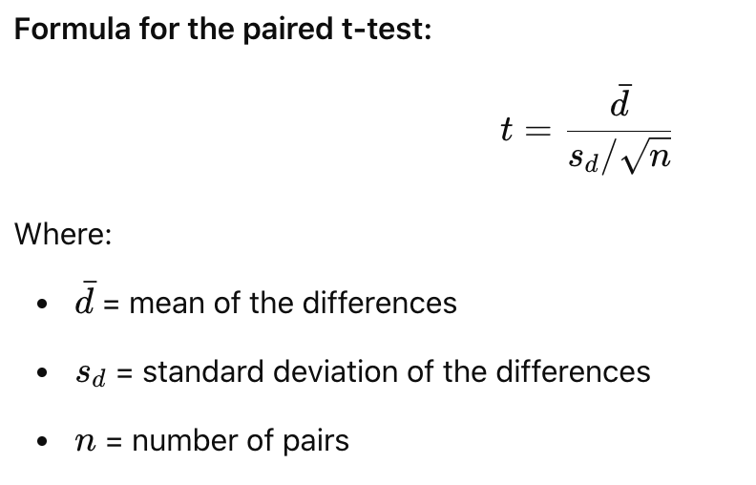

**Simpson’s paradox**

[Youtube link](https://www.google.com/search?q=%E6%9D%8E%E6%B0%B8%E4%B9%90%E8%80%81%E5%B8%88%E8%AE%B2%E4%B9%94%E4%B8%B9%E8%A9%B9%E5%A7%86%E6%96%AF%E5%93%AA%E4%B8%AA%E4%BA%BA%E6%9B%B4%E5%BC%BA&sca_esv=9bc7cd2d6745352a&sxsrf=ADLYWII64gCM0VgQ2Ou-1a0Dm_g_2JBBLg%3A1732429696532&ei=gMdCZ_acIOrVkPIPmpXfiQ0&ved=0ahUKEwj23KPFq_SJAxXqKkQIHZrKN9EQ4dUDCA8&uact=5&oq=%E6%9D%8E%E6%B0%B8%E4%B9%90%E8%80%81%E5%B8%88%E8%AE%B2%E4%B9%94%E4%B8%B9%E8%A9%B9%E5%A7%86%E6%96%AF%E5%93%AA%E4%B8%AA%E4%BA%BA%E6%9B%B4%E5%BC%BA&gs_lp=Egxnd3Mtd2l6LXNlcnAiMOadjuawuOS5kOiAgeW4iOiusuS5lOS4ueipueWnhuaWr-WTquS4quS6uuabtOW8ujIIEAAYgAQYogRIxAZQkARYkARwA3gAkAEAmAHOAaABzgGqAQMyLTG4AQPIAQD4AQL4AQGYAgSgAtoBwgILEAAYgAQYsAMYogSYAwCIBgGQBgSSBwUzLjAuMaAHigE&sclient=gws-wiz-serp#fpstate=ive&vld=cid:6916f3ba,vid:Ljvlby3yZFQ,st:0)

A trend appears in different groups of data but disappears or reverses when these groups are combined).

Reasons:

1. Sampling is not uniform; sample size of your segments is different. There is a disproportionate allocation of groupings among experimental groups

2. Success rate is very different for different groups: This different group is an overlooked confounding factor. i.e. there are significantly more guys applying for physics department which has a higher admission rate, and significantly more girls applying to literature which has a lower admission rate, So the aggregate result shows higher overall admission rate for guys

Solutions:

* Simple randomization: data in each of the sample groups have opportunity to be equally distributed to any group and the method manages both known and unknown variables
* Stratified sampling: process of dividing members of the population into homogeneous and mutually exclusive subgroups before sampling.
  + Identify confounding variables: identify any potential confounding variables that could influence the overall relationship
  + Stratify confounding variables: divide your data into homogeneous subgroups or strata based on confounding variables. We sample proportionally to the size of each strata.
  + Testing within each stratum: perform the same statistical test within each stratum
  + Compare adjusted results
  + Recombine or aggregate carefully: weighted averages or other statistical methods (regression) when aggregating data

Issues with stratified sampling:

Post-test segmentation, however, will impact the statistical validity of your segments.  
1. The sample size of your segments is too small. Your test would be underpowered. You stopped the test when you reached the calculated sample size, but at a segment level the sample size is likely too small and the lift between segments has no statistical validity.  
2. The multiple comparison problem. The more segments you compare, the greater the likelihood that you’ll get a false positive (type I error) among those tests. With a 95% confidence level, you’re likely to get a false positive every 20 post-test segments you look at. You can correct this with Bonferroni correction to reduce the risk of false discoveries.



**Causal inference**

**Why A/B testing is not working?**

* Network effect:
  + Social media/communication (Meta): users talk – treatment users interact with control users
  + Marketplaces (Uber, Doordash, Airbnb): resources shared – users share the same pool of drivers, dashers and listings

**Problems with observational data:**

* Identify users who expose to negative content vs. users who didn’t have exposed to negative content and then compare engagement metrics
* There could be confounders that would also impact both treatment and outcome
* Ads and news feeds are personalized, and users who are shown certain content may be more engaged

**Solution**: Statistically control for confounders by holding them at constant values and see whether treatment still affect the outcome or not: regression or matching

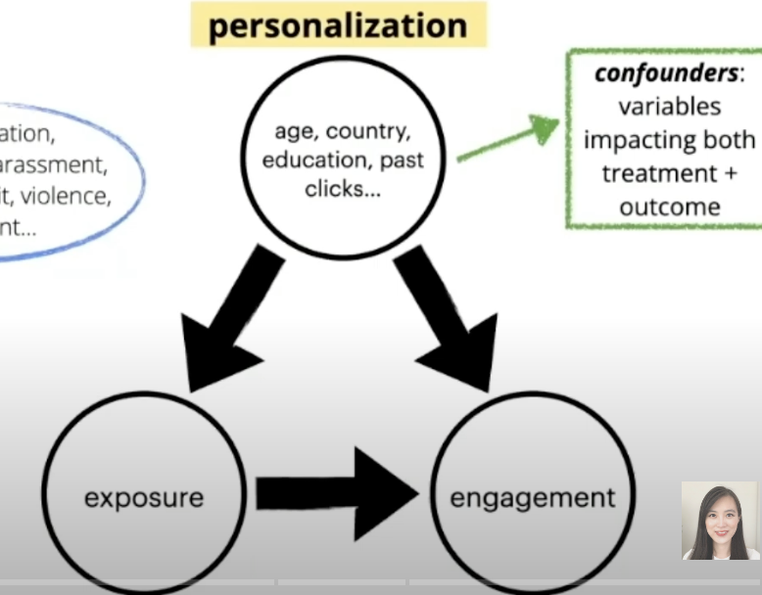

**Regression:**

* Model: lm(engagement ~ exposure + age + country + education + …, data = harmful)
* Interpret partial slope: how much being exposed to harmful content affects engagement when control variables are held at any constant values

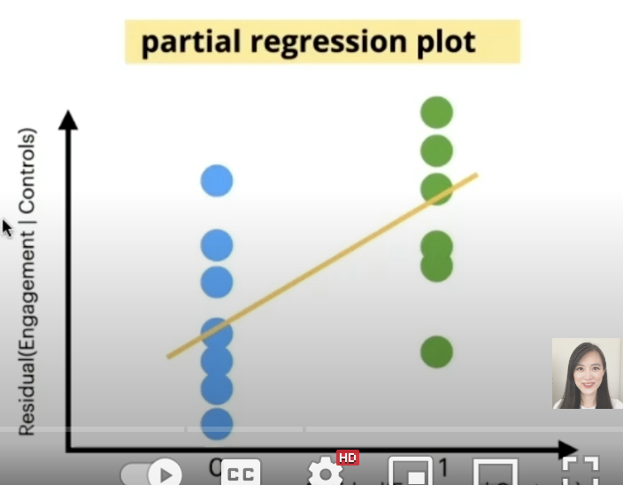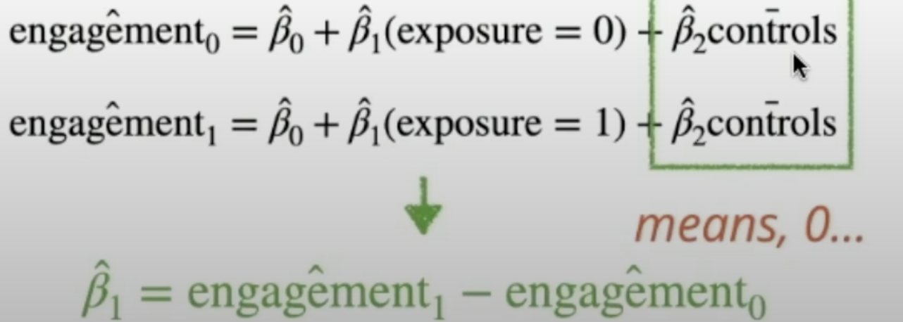 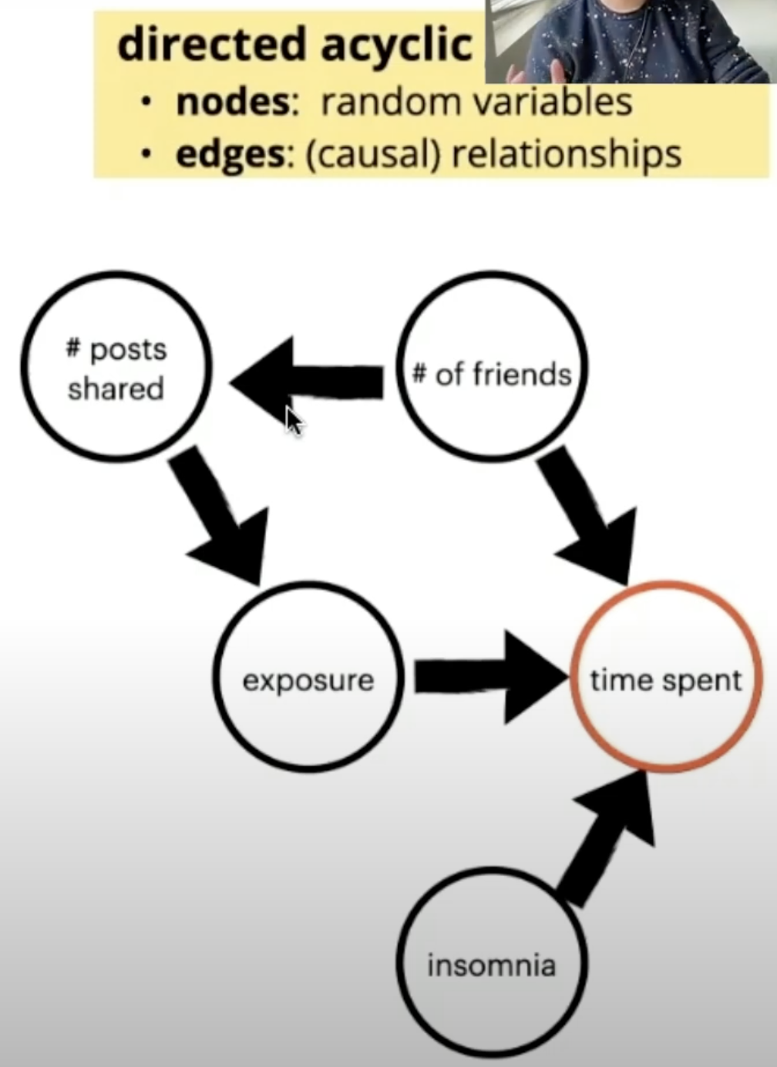

* Omitted variable bias: relevant variables left out
* Functional form: if controls have non-linear (quadratic) influence on outcome, linear regression cannot control them cleanly
* Causal structure:
  + Mediators: (middle of a chain): control for # shared posts 🡪 social circle size no longer has influence on exposure to harmful content
  + Colliders: (common effect): controlling for time spent late at night 🡪 spurious correlation between popularity and insomnia

**How to reduce variance under small sample size?**

* CUPED

**How to handle covariant imbalance?**

* **Pre test:** A/A test
* **Post test**:
  + Diff-in-diff
  + Propensity score matching

**Interrupted time series (ITS)**

You use same population for control and treatment, and you vary what the population experiences over time

Before an intervention, create a model that can provide an estimate for the metric

After the intervention, treatment effect = average difference between actual values for the metric and those predicted by the model

Concerns: confounding effect: seasonality

Changing back and forth multiple times will help reduce the likelihood

**Instrumented Variables (IV)**

Technique to approximate random assignment

**Diff in Diff**

Assumption: parallel trends assumption is a key assumption in diff in diff method for estimating treatment effect. It states that the trend in outcomes for control units would be the same as the trend for treatment units if they had not been treated. it requires that in the absence of treatment, the difference between the treatment and baseline groups is constant over time

Use case: Controlling for pre-experimental bias, when there is imbalance between control and treatment

Procedure

* We first find the difference between the treatment group between the post and pre period.
* We then do the same for the baseline group.
  + The intuition here is that for the treatment this change is due to 2 things.
    - Treatment effect
    - Natural variation over time
  + For the Baseline group this change is just due to natural variation over time.
* We find the difference between these groups.
  + This isolates the effect of treatment.

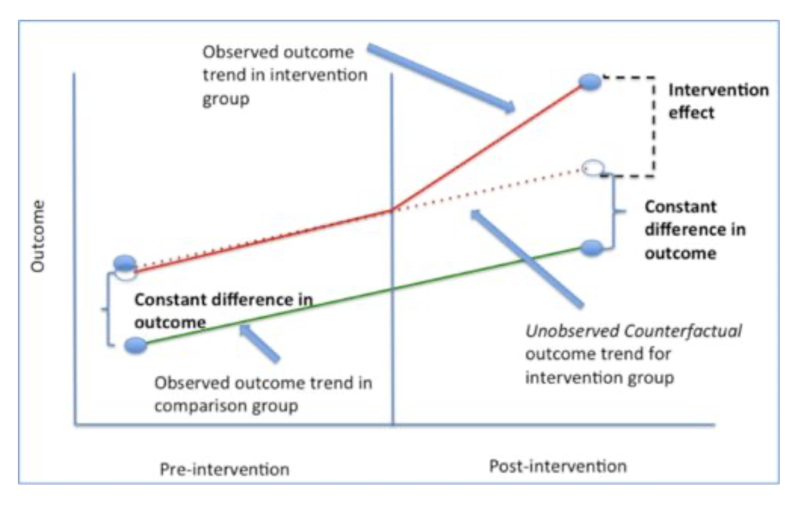

Why use regression-based DiD analysis?

* We’ve shown that we can use simple arithmetic to estimate the impact of the treatment so why should we use linear regression?
  + When you run a regression, it calculates the standard error and p-values for you so you can see if this change was significant.
  + It allows you to add other variables to the model to control for. This can reduce the error term in the regression and increase your estimate of the treatment impact.
* One major assumption of DiD is that it requires that in the absence of treatment, the difference between the treatment and baseline groups is constant over time. Because this is an experiment this condition should hold (although since we run multiple experiments at once there could be some things that aren’t constant).

Diff and Diff regression

* In order be able to run a Diff in Diff regression we need a few things from our data.
  + A row for each user in the post and pre period
    - If there was a new user that started during the experiment then we wouldn’t have a row in the pre period.
  + A column for our outcome variable (e.g. contacts per user)
    - This should either be normalized on a per day basis or calculated over the same time window.
  + A column that signifies if a user was in the baseline or treatment group (0 = baseline).
  + A column that signifies if the data refers to the pre or post period (0 = pre period).

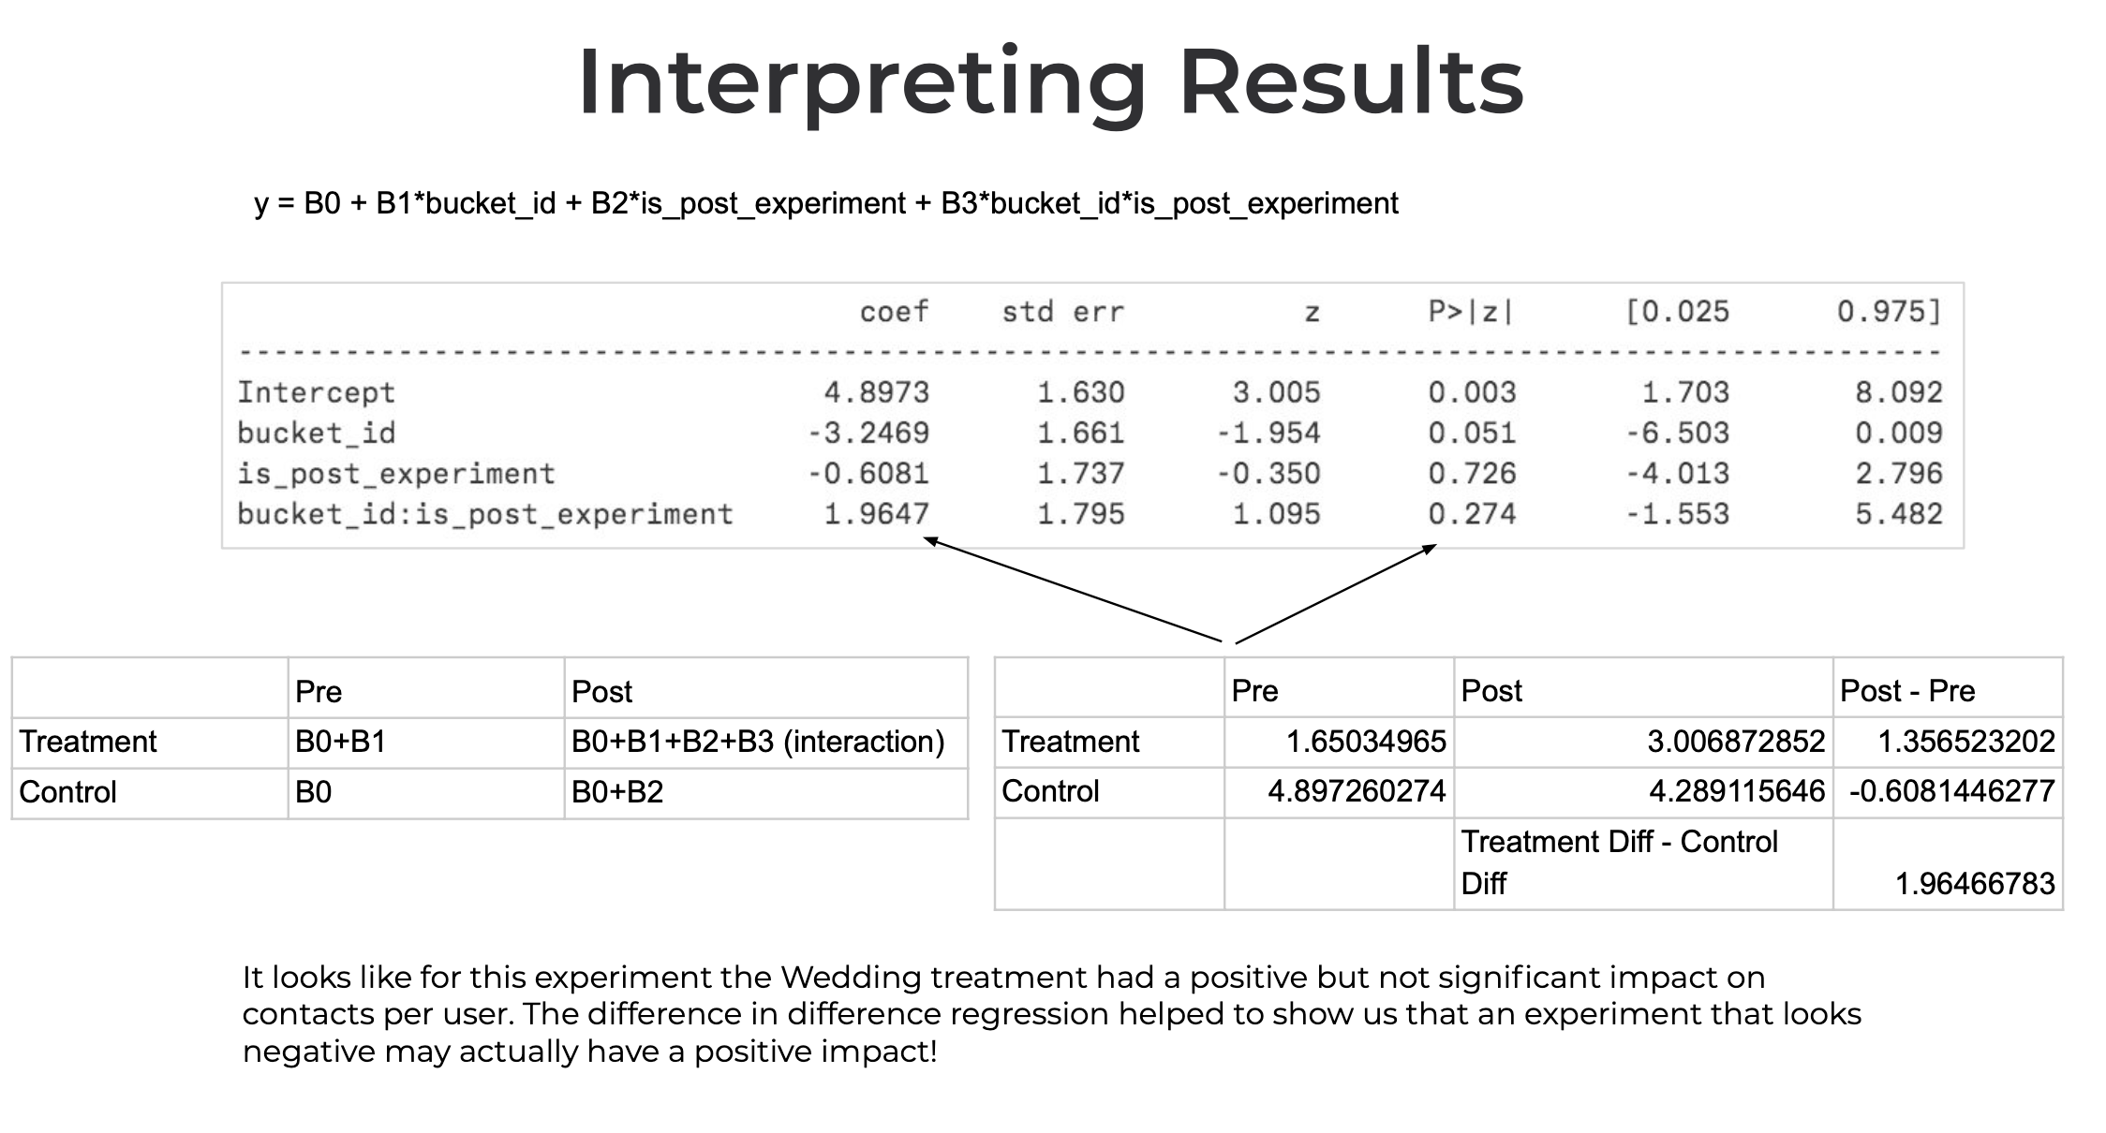

In real-world settings with multiple time periods and individuals or locations, you can use a regression-based approach to implement DiD. The basic regression model for DiD is:



* **Post**: Indicator variable (1 if post-treatment, 0 if pre-treatment).
* **Treatment**: Indicator variable (1 if Region A, 0 if Region B).
* **Post × Treatment**: Interaction term. β3 captures the DiD effect, which is the causal impact of the campaign.

**Interpretation of coefficients:**

* β0: The intercept term, representing the baseline sales for the control group before the treatment.
* β1: The coefficient on the Post variable, representing the overall trend in sales across **both treatment and control groups** after the treatment (i.e., the average post-treatment effect across both groups).
* β2: The coefficient on the Treatment variable, representing the difference in sales between the treatment and control groups in the **pre-treatment period**.
* β3: The coefficient on the interaction term, Post x Treatment, represents the difference-in-differences estimator. This coefficient is the key result and represents the causal effect of the price discount on sales.

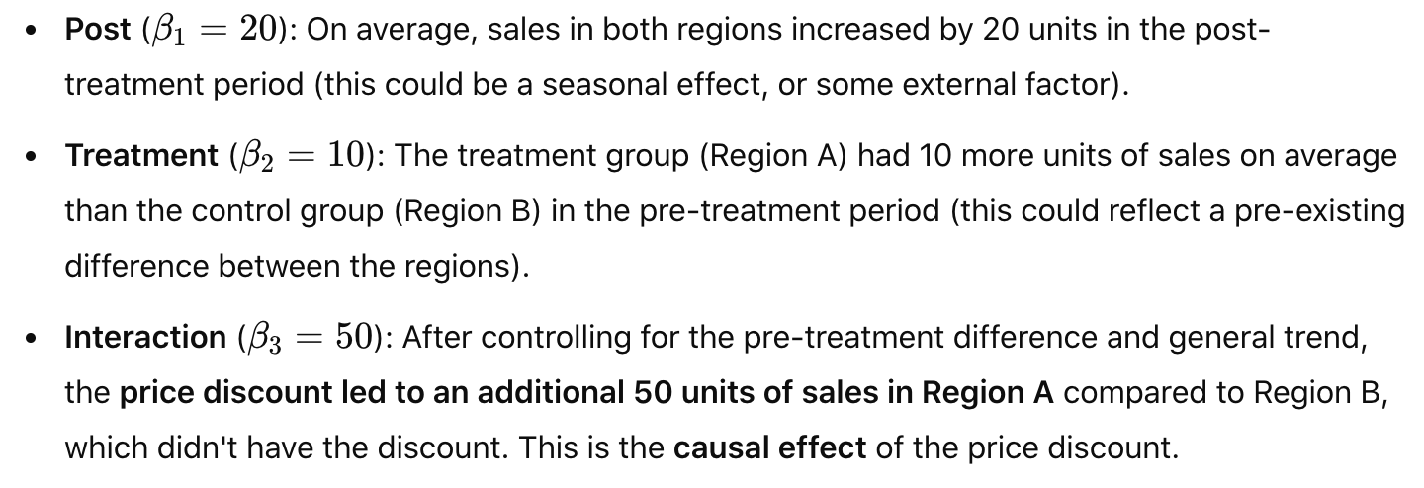

**Propensity score matching**

<https://medium.com/towards-data-science/causal-inference-with-python-a-guide-to-propensity-score-matching-b3470080c84f>

PSM: Find pairs between control and treatments, and then we measure the average delta between each pair to attribute any difference we find to the treatment. By matching on propensity score, PSM ensures that both groups are similar in terms of observed covariates, which helps reduce selection bias and makes the groups more comparable.

Hypothesis: feature A drives certain output metrics i.e. retention

Summary steps:

* Identify list of covariates that could impact output metrics; controlling these isolates the treatment effect to feature A
* Assign users matching score: Build a regression model to predict whether a user use feature A, so for every user, we label them with how likely if a user will use feature A. (Logistic regression to predict users using certain feature is basically taking the current labeling of users using this feature as output variable y and fit some characteristics of users for the prediction.) (If we pull distribution of PS score for two groups, we will see two overlapping distributions; what we want to compare is the matched area.) 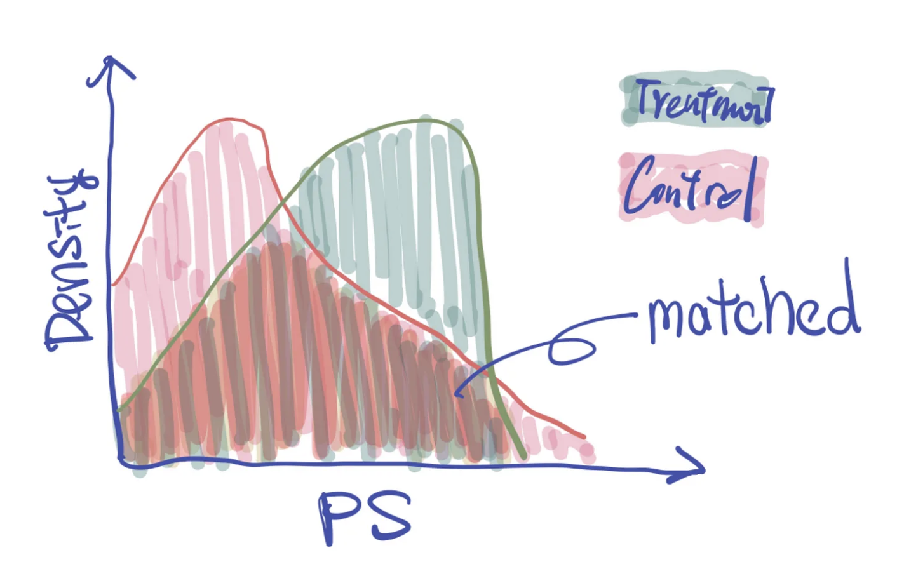
* Match treatment and control groups: For users actually used feature A, set them in treatment and match with non-feature A user with same score in control. There will be unmatched users left. For the match, we use a difference of +/- 0.5% for matching. Our sample size will also start to change as some samples may not find a match.
* Measure treatment effect from matched groups: Calculate lift in key metrics with statistical test
* Sanity check the result via AA test

Propensity score matching criteria:

Greedy vs. optimal, 1 to 1 vs. 1 to many, caliper radius

* For each observation in the treatment, use KNN to find the top N closest neighbors in the control group based on the propensity score (here, use a fixed radius/caliper, such as 0.05 or use 25% of the standard deviation of the propensity score as radius/caliper)
* If 1:1 matching, pick the closest one as the match
* If 1:M matching, pick the M closest ones from the top N as the match
* A match cannot be reused if replacement is true
* Drop observations without any match

One way to see the matching effect is to show the mean difference of the features from control vs. treatment groups before and after the match - We hope to decrease the differences via matching, i.e., the characteristics of the deals are more similar in both control and treatment groups after matching.

Concerns on PSM: Only observed covariates are accounted for and unaccounted factors may result in hidden bias

**CUPED (Controlled Experiment Using Pre-Experiment Data)**

<https://towardsdatascience.com/how-to-double-a-b-testing-speed-with-cuped-f80460825a90>

<https://medium.com/walmartglobaltech/how-walmart-leverages-cuped-and-reduces-experimentation-lifecycle-eae2446c2ee4>

Controlled-experiment Using Pre-Existing Data (CUPED) is a variance reduction technique created by [Microsoft in 2013](https://exp-platform.com/Documents/2013-02-CUPED-ImprovingSensitivityOfControlledExperiments.pdf).

In short, CUPED uses pre-experiment data to control for natural variation in an experiment’s metric. By removing natural variation, we can reduce variance, thus shrinking our confidence intervals, and running test with smaller sample size. Don’t sacrifice anything but get results quicker.

The variance in any experiment is influenced by both the signal (true treatment effect) and the noise (irrelevant or confounding factors). By using CUPED:

* The regression model explains more of the variance from the covariate in pre-experiment data, which reduces the unexplained noise in the data.
* Since the explained variance is removed, the remaining variance (residual variance) is reduced, making it easier to detect the signal - the effect of the treatment even with a smaller sample size.

**CUPED Steps:**

**1. Define the Outcome Metric**

The outcome metric is the variable you want to measure the effect of the treatment on. In this case, the user conversion rate (whether or not a user made a purchase) will be your outcome variable.

Identify a relevant pre-experiment covariate (e.g., past behavior, historical conversion rates) that is correlated with the outcome variable (e.g., future conversions).

**2. Collect Pre-Experiment Data (Signal)**

Before the experiment starts, you gather pre-experiment data. This data could include historical metrics, such as:

* Past conversion rate for each user (conversion rate in the past month).
* Number of sessions or page views per user in the past.
* Other user features like demographics, previous purchase frequency, etc.

**3. Randomly Assign Users to Treatment and Control Groups**

Randomly assign users to the Treatment group (with the new recommendation system) and the Control group (with the old system).

Ensure that the assignment is random to minimize bias between the two groups.

**4. Fit a regression model: Model the Relationship Between Pre-Experiment Data and Outcome**

The key idea behind CUPED is to use the pre-experiment data to account for user differences before the experiment starts, so you can more accurately measure the treatment effect.

Fit a regression model that predicts the outcome (conversion rate in this case) based on the pre-experiment data.

In this case, you would regress past conversion rate on user features to model the expected conversion for each user.

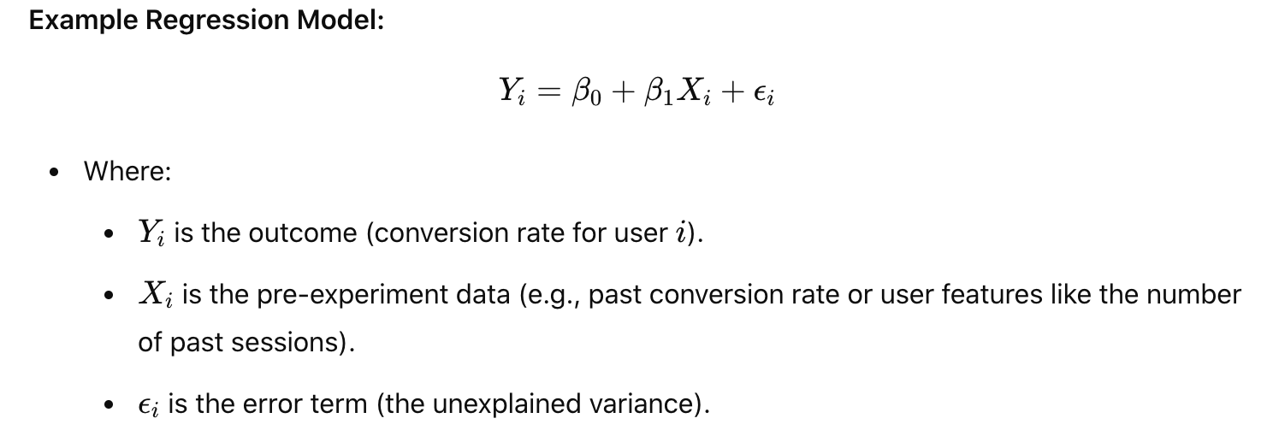

**5. Calculate the Residuals (Center the Pre-Experiment Data)**

Once you’ve fit the regression model, you calculate the residuals. The residual is the difference between the observed and predicted conversion rate for each user. which represent the portion of the outcome that cannot be explained by the covariate. This is also called adjusted conversion rate.

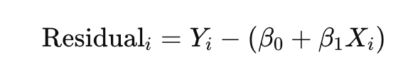

**6. Adjust the Experiment Outcome Using Residuals**

Now that you have the residuals, you adjust the actual conversion rates in the treatment and control groups by removing the variance explained by the pre-experiment data.

In effect, you're subtracting out the variance that is explained by past user behavior, which makes the experiment more sensitive to detecting the treatment effect.

You can adjust the treatment and control group conversion rates like this:

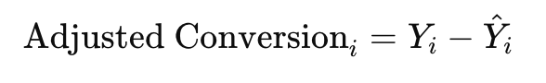

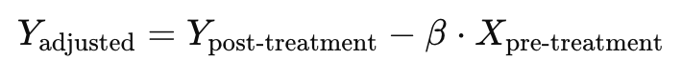



This adjustment essentially "normalizes" the conversion rates, accounting for differences in baseline user behavior.

**7. Perform Statistical Analysis**

After adjusting for the pre-experiment data, you can now analyze the treatment effect. You can compare the adjusted conversion rates between the treatment and control groups using a statistical test (e.g., a t-test or ANOVA).

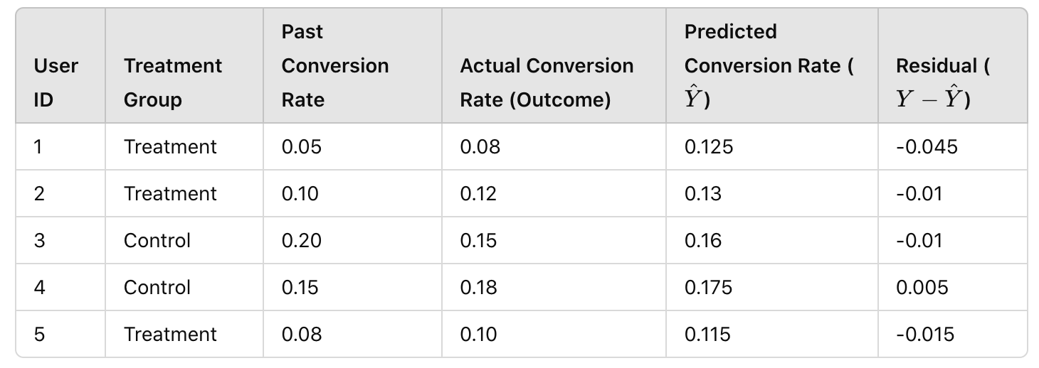

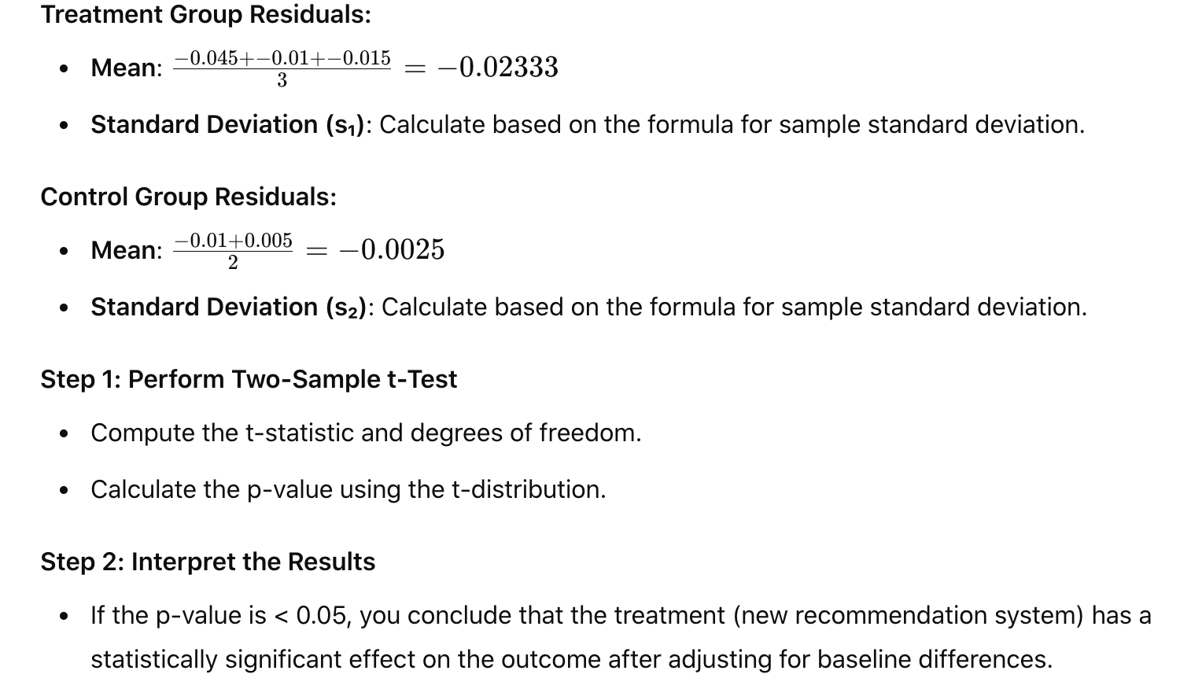

**Note:**

CUPED does not directly adjust for covariate imbalance

CUPED improves the precision of the treatment effect estimate by reducing variance in the post treatment outcome using pre treatment data. But it does this without addressing how the treatment was assigned in the first place.

For example, if there were baseline differences in age, income, or any other covariate between the treated and control groups, CUPED will help adjust for those differences in terms of the outcome, but it doesn’t correct for the imbalance in how individuals were assigned to the treatment or control group.

**Confounding**:

* Selection bias: data is biased due to the way they are collected
* Omitted variable bias: important variables are omitted
* Solution:
  + Stratification to create multiple categories or subgroups in which the confounding variables do not vary much, and then test significance and strength of associations using chi square for each strata.
  + Use multivariable regression models (e.g., linear or logistic regression) to control for multiple confounders simultaneously: include confounders as covariates in the model
  + Propensity score matching can help balance confounders between treated and untreated groups by creating a matched sample based on the propensity score

**Machine learning modeling:**

Supervised learning: only inputs without output data; algo has to find structure in data

* Regression
* Classification

Unsupervised learning:

* Clustering: group similar data points together
* Dimensionality reduction: compress data with fewer numbers
* Anomaly detection: find unusual data points]

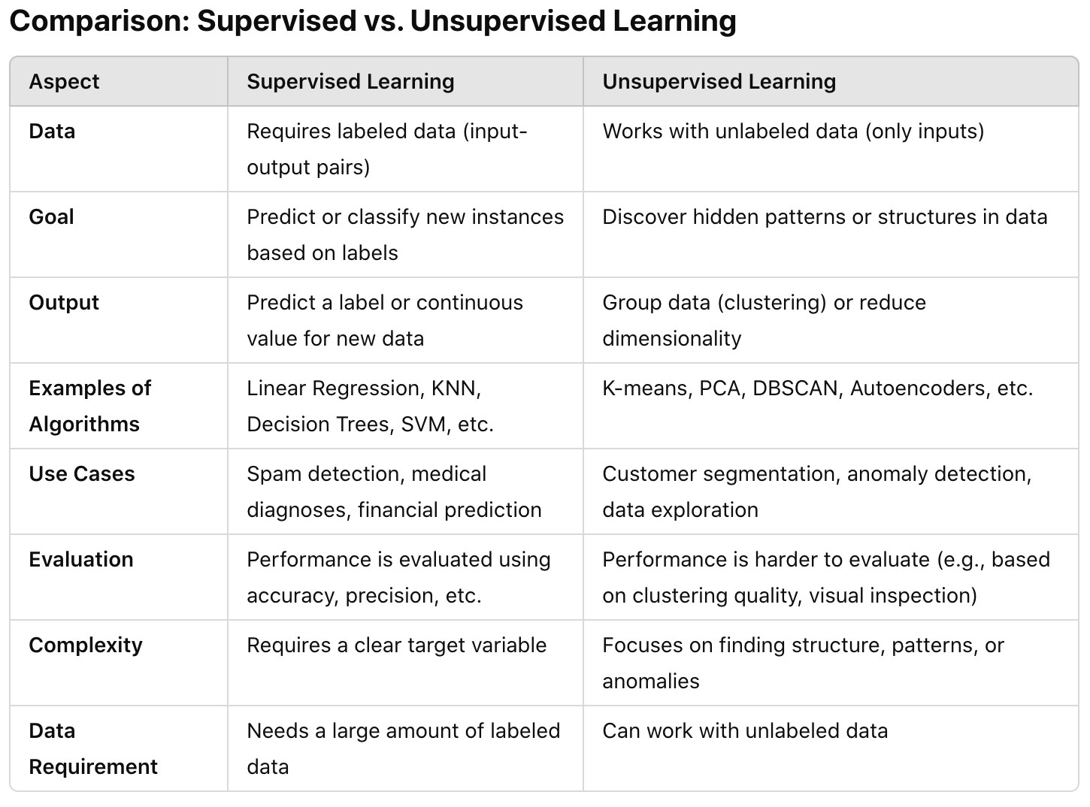

**Machine learning procedure:**

Understand the problem 🡪 Data collection 🡪 Data exploratory & Data cleaning 🡪 Feature engineering 🡪 Building model (model selection) 🡪 Train model 🡪 Evaluate model performance (confusion matrix: precision recall) 🡪 Deploy model 🡪 Rebuild/iterate model if needed

**Data collection**:

* Intentionally source more examples of edge cases via data augmentation or artificial data synthesis
* Simulation: simulate the environment i.e. autonomous car

**Data exploration**:

* Summary statistics i.e. mean, median, quantiles
* Visualize distribution: histogram through binning (i.e. age, weight)
* Relationship between variables using correlation matrix: check for correlation among variables (features with > 0.8 correlation are suspicious), look for variables strongly correlated with target variable
* Check for multicollinearity VIF score (VIF is conservative threshold. >10 big issue with model and VIF should not be higher than 2 or 3): two or more independent variables are highly correlated with each other.
* Check if dataset size is sufficient: rule of thumb is 50 records per feature

**Data cleaning**:

* Check missing values:
  + Remove missing data values: Very large training data and % missing value is low, then ignore missing value: dropna()
  + Input missing data based mean or median values: fillna(); data['age'].fillna(data['age'].mean(), inplace = True)
  + Use a model or distribution to impute missing data: treat missing value as training parameter
* Outliers: remove outright, truncated or left as it is, depending on source and business implications
* Add a constant column for intercept: Adding a constant column for the intercept is a common step in regression modeling to ensure the model has an intercept term. By adding a column of ones to the dataset, we allow the model to learn a bias term, representing the baseline prediction when all other predictors are zero.

**Feature engineering**:

* Transformation: apply a function i.e. log, capping, or flooring can help when data is skewed or want to make data conform to a more standard statistical distributions; Income: long tail 🡪 take log
* Encode categorical features
  + One hot encoding: too sparse, no meaning, loss of semantic information (Semantics in the original categorical variable are lost because the relationship between the categories is not preserved in the encoding.)
  + Embedding:
    - Dense Representation: Unlike one-hot encoding, which creates a sparse vector (mostly filled with zeros), embeddings provide a dense vector (much smaller in size, containing meaningful values).
    - Similarity Capture: In embeddings, the distance between vectors in the vector space can reflect the semantic similarity between items.
    - Learned During Training: Embeddings are typically learned during the training process of a machine learning model (e.g., through backpropagation in neural networks), allowing the model to automatically learn useful representations for the data.
  + Hashing: Hashing transforms input data into a fixed-length numerical value using a hash function; used in ML to map high-cardinality categorical variables into a fixed-size space, and output of one hot encoding would be too long.
* Bucket / binning: breakdown continuous variable into discrete bins / categorical variables, reducing noise associated with data; i.e. Age or video length: use quantile to turn into categorical variables
* Normalization: for continuous variables; scale numerical features
  + Improves model performance: Many machine learning models (like linear regression, logistic regression, SVM, and k-means clustering) assume that features have similar scales. If features vary widely in magnitude (for example, one feature ranges from 0 to 1, and another ranges from 0 to 1000), the model can be biased towards the larger magnitude features. Standardization makes sure all features have comparable variances
  + Standard or minmax scalar: all data lies between 0 and 1
* Dimensionality reduction: generate a reduced set of uncorrelated features, such as PCA

Feature engineering for logistics regression

**How to handle imbalanced data?**

* **Oversampling the Minority Class**
  + **SMOTE**: It generates synthetic samples by interpolating between existing minority class samples.
  + **Random oversampling:** Randomly duplicating examples from the minority class to increase its size.
  + **Pros:** Makes sure that the minority class has enough samples for the model to learn from.
  + **Cons:** Can lead to overfitting because the same minority class samples (or synthetic duplicates) are seen multiple times.
* **Undersampling the Majority Class**
  + **Random Undersampling**: Randomly removing samples from the majority class.
  + Pros: Can be effective when the dataset is very large, and reducing the majority class does not lead to significant information loss
  + Cons: Risk of losing potentially valuable data, which can degrade model performance
* Model metrics
  + Focus on precision, recall, F1 instead of accuracy
* Weighted logistic regression: Assign weights during training
  + More weights to higher samples and lower weights to smaller samples

**How to handle outliers?**

1. Logistic Regression (Sensitive to Outliers 🚨)

Logistic regression is based on linear regression, which minimizes a loss function (log loss or cross-entropy) that can be heavily influenced by extreme values. Outliers in features (independent variables) can skew model coefficients, leading to poor decision boundaries.

🔹 How to Handle Outliers in Logistic Regression?

* Robust Scaling: Use RobustScaler (based on median & IQR) instead of StandardScaler.
* Winsorization: Cap extreme values to reduce their influence.
* Transformations: Log or power transformations can mitigate outlier effects.
* Regularization (L1/L2): Helps reduce sensitivity to large coefficients caused by outliers.

2. Random Forest (Handles Outliers Well ✅)

Random forests use decision trees, which split based on feature values rather than relying on distance-based calculations.

Outliers do not significantly affect tree splits because trees recursively partition the data and aren’t influenced by extreme values as much as linear models.

🔹 When Can Outliers Be a Problem?

If outliers are extreme but frequent, they can bias splits and affect feature importance scores. When using Mean Squared Error (MSE) as a criterion, outliers can slightly affect regression tasks.

🔹 How to Handle Outliers in Random Forest?

* Use Median-Based Splits: Instead of MSE, use Mean Absolute Error (MAE) in regression trees to reduce outlier impact.
* Limit Tree Depth: Prune deep trees to prevent outliers from creating unnecessary splits.
* Use More Trees: Larger ensembles reduce variance and smooth outlier effects.

3. Boosting (Gradient Boosting, XGBoost, LightGBM, CatBoost) (Moderately Sensitive 🤔)

Boosting methods build trees sequentially, where each new tree corrects errors from the previous one.

If an outlier causes a large error, the next tree will try to compensate for it, potentially leading to overfitting.

XGBoost, LightGBM, and CatBoost have built-in mechanisms to reduce outlier influence, but sensitivity depends on hyperparameters.

🔹 How to Handle Outliers in Boosting Models?

* Use Robust Loss Functions:
  + Huber loss (combination of MSE and MAE) reduces sensitivity to extreme values.
  + Quantile loss helps handle skewed distributions.
* Regularization Techniques:
  + Learning Rate Decay prevents overfitting to outliers.
  + L1/L2 Regularization on weights stabilizes the model.
* Use Tree Constraints:
  + Max Depth: Limits how deeply the model can fit outliers.
  + Min Child Weight: Prevents small noisy samples from being overfitted.

**Model selection criteria**

* Training & prediction speed: linear regression is quicker than neural network for same amount of data
* Budget: neutral network is computationally intensive
* Volume & dimensionality of data: neural network can handle large amount of data and higher dimensional data
* Categorical vs. numerical features: linear regression cannot handle categorical variables and need one hot encoding vs tree can handle directly
* Explainability: regression is more interpretable than neural network

If you are dealing with **so much data**, can look into **sampling** **techniques**:

* Random sampling: sample with or without replacement
* Stratified sampling: sample from specific groups among the population

**Test split:**

* Training, validation and test split: 70% 15% 15%
* Deep learning models: 98% 1% 1%

**Model Deployment**

Deployment type:

* Deploy online: model predictions are made in real time, have a caching layer of cashed features; downside: computationally intensive to meet latency requirements
* Deploy in batch: predictions are made periodically (recommendation system), no need for immediate results nor require high throughput; downside: batch predictions may not be available for new data, recommendation list may not be updated until next batch is computed

Deployment issues - Model degradation:

* Underlying distributions of data for your model change
* Training serving skew: performance hit between the model in training and evaluation time vs. when model is served in production
* How often to retrain model, what event triggers a model refresh, how much new data to use vs. how much to rely on historical data

**Model Iteration**

Error analysis: analyze wrong predictions manually.

**Bias variance trade off**

* Bias: how close the model’s predicted values come to the true underlying f(x) values, with smaller being better
  + High bias occurs when the model is too simplistic and cannot capture the underlying patterns in the data. Low bias means the model makes fewer assumptions, potentially able to capture more complex patterns in the data
  + **Mean squared error**
* Variance: the extent to which model prediction error changes based on training inputs, with smaller being better
  + High variance occurs when the model is too complex and overfits the training data. Low variance says the model’s predictions are stable and consistent across different subsets of the data.
  + **Variance of negative mean squared error**

The **trade-off** comes from the fact that bias and variance are inversely related:

* **Increasing model complexity** (e.g., using a more complex model like a high-degree polynomial or a deeper neural network) tends to **decrease bias** (better fit to the training data), but **increase variance** (model becomes more sensitive to small changes in the data).
* **Decreasing model complexity** (e.g., using a simpler model like linear regression) tends to **increase bias** (underfitting the data), but **decrease variance** (model becomes more robust to fluctuations in the training data).

How to manage bias variance trade off?

* Increase model complexity: decrease bias and increase variance
* Decrease model complexity: increase bias and decrease variance
* Cross validation: identify optimal model complexity
* Ensemble methods: combine multiple models to reduce variance or bias
  + Bagging (random forest) reduces variance by averaging over multiple models
  + Boosting (gradient boosting) reduces bias by iteratively improving predictions
* Regularization: L2 regularization (ridge) and L1 regularization (lasso) for linear models help control model complexity, prevent overfitting and reduce variance
* Model selection: use different models and compare their performance on validation set

|  |  |  |
| --- | --- | --- |
|  | Bias | Variance |
| Linear models  (linear regression, logistic regression) | High – have strong assumptions about relationship | Low – unlikely to overfit; underfitting risk |
| Decision trees | Low – can model complex, non-linear relationships | High – sensitive to small changes in data; overfitting risk (prune tress) |
| Random forest | Low – can model complex, non-linear relationship | Low – aggregates predictions from decision tress, which reduces overfitting and variance (compare to decision trees) |
| KNN | Low – for large k values bc model can fit complex relationship by averaging over many neighbors | High – for small k bc model becomes highly sensitive to individual data points; select an optimal k |

Complex model: add more polynomials and even multi collinearity; coefficient is small

Simple model: coefficient is large

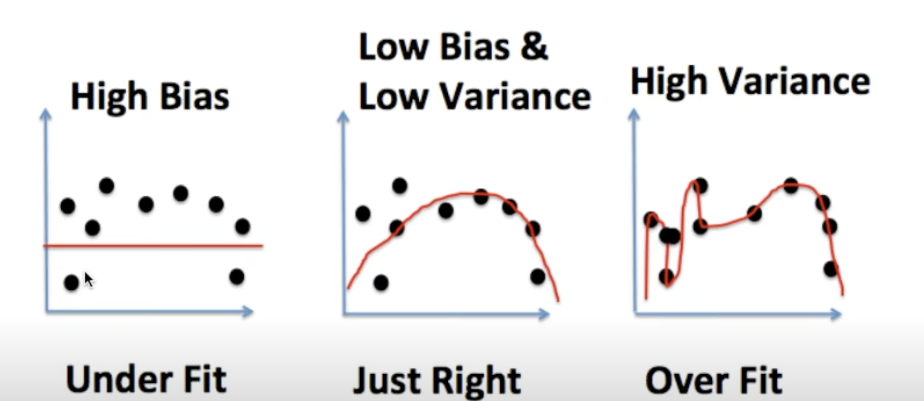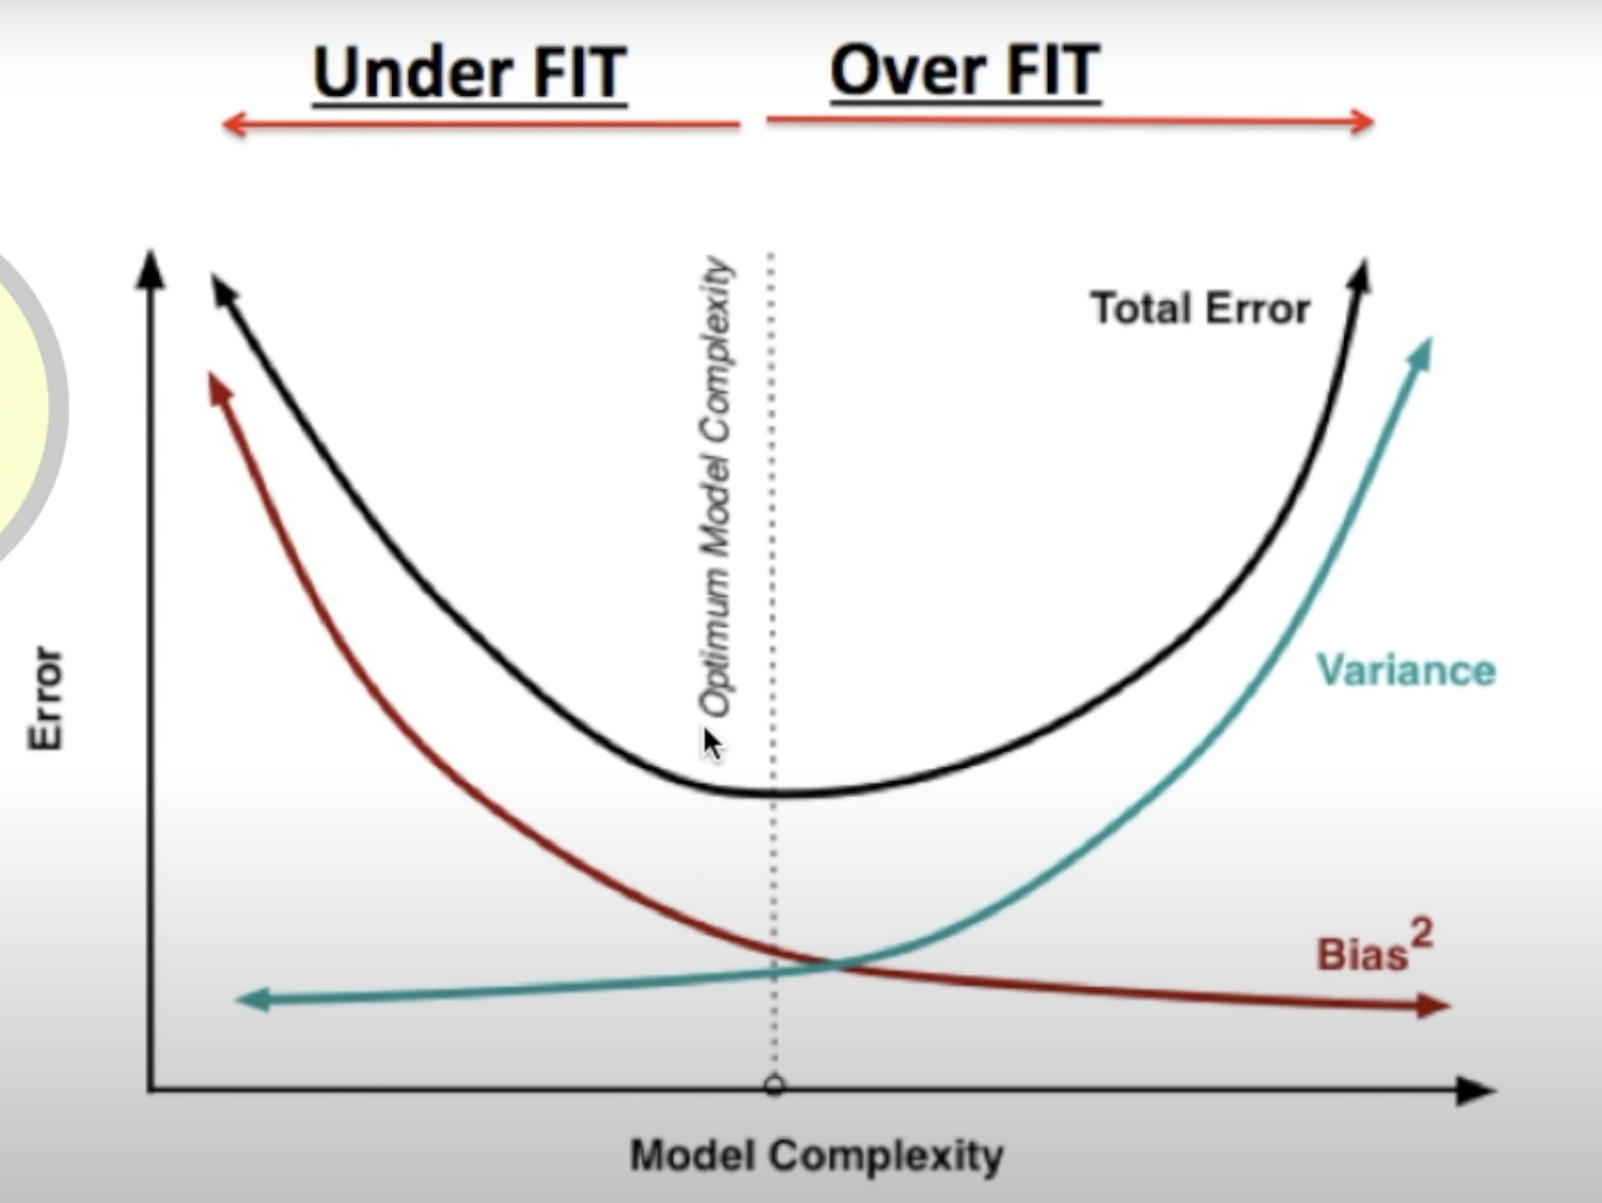

**Gradient Descent**

Take small steps in the direction of steepest descent for a particular objective function. For convex functions, the gradient descent algo eventually finds the optimal point by updating the below equation until the value at the next iteration is very close to the current iteration (convergence); it calculates the negative of the gradient of the cost function and scales that by some constant which is known as learning rate, and then moves in that direction at each iteration of the algo.

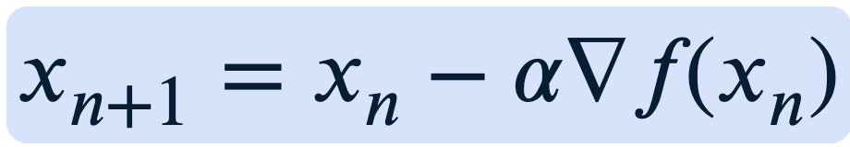

1. Take the derivative of the loss function for each parameter in it (take the gradient of the loss function)
2. Pick random values for the parameters
3. Plug the parameter values into the derivatives (to get the slop)
4. Calculate the step sizes: step size = slope * learning rate
5. Calculate the new parameters: new parameter = old parameter – step size
6. Go back to step 3 until step size is very small or reach the maximum number of steps

Note: stochastic gradient descent: use a randomly selected subset of the data at every step rather than the full dataset. This reduces the time spent calculating the derivatives of the loss function

**Linear regression**

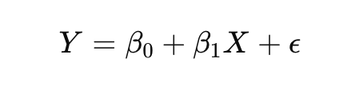

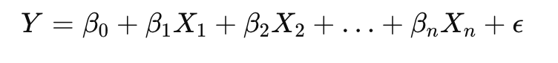

Coefficient:

* X is continuous variable: A unit increase in x results in an increase in average y by β1 units, all other variables held constant
* X is categorical variable: one-hot encoding of categorical variables (X1, X2): Average y is higher by β1 units for X1 than for X2, all other variables held constant

Accuracy:

* Residual standard error (RSE): measure of lack of fit

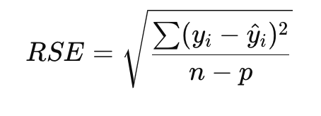

* R-squared statistic: **R-squared (**R^2**)** is a statistical measure that indicates the proportion of the variance in the dependent variable that can be explained by the independent variables in a regression model. It is often used to assess the goodness of fit of a model.

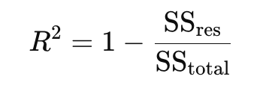

* + SSres is the sum of squared residuals (the differences between the observed and predicted values).
  + SStotal is the total sum of squares (the variance of the dependent variable y: how much actual data points deviate from the mean of dependent variable).
  + 0 < R^2 < 1: In most real-world cases, R^2 will fall somewhere between 0 and 1. A value closer to 1 indicates a better fit, meaning the model is able to explain a larger portion of the variance. A value closer to 0 indicates a poorer fit, meaning the model explains very little of the variance.
  + A high R² does not necessarily mean the model is good—it could just mean the model is overfitting.
  + When you add more predictors to your model, R² will almost always increase, even if the additional predictors don't actually improve the model's predictive power.
  + The **adjusted R-squared** corrects for this by penalizing the addition of irrelevant predictors. It gives you a more reliable measure when comparing models with a different number of predictors.

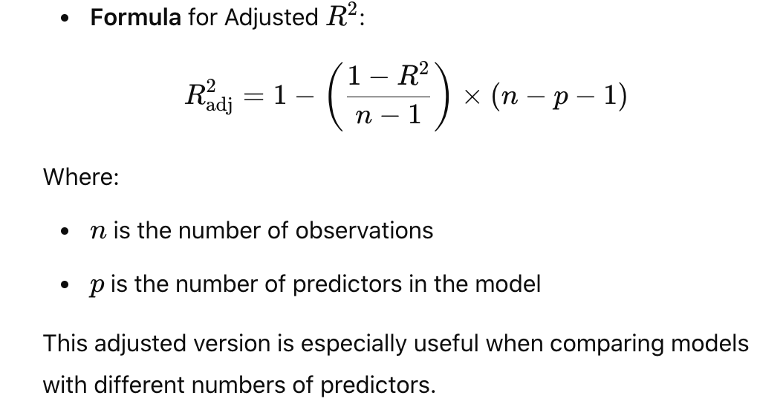

How to reduce model complexity of a regression model?

* Subset selection: narrow down number of features in the model
* Forward stepwise selection: start with empty model and iteratively add the most useful predictor
* Backward stepwise selection: start with full model and iteratively remove the least useful predictor

4 **assumptions** of linear regression:

* Linearity: Relationship between independent and dependent variables is linear
  + Use a scatter plot of x and y
* Homoscedasticity: Errors/residuals have constant variance
  + Use scatter plot of residuals vs. fitted value and see if relationship is nonlinear; if not, then should try to transform the dependent variable or include nonlinear terms in the model
* Independence: All observations (errors/residuals) are independent of one another; no multicollinearity; no correlation between residuals and Y
  + Use a scatter plot of residuals vs. fitted value
* Normality: Response or errors/residuals are normally distributed
  + Use histogram of residuals or QQ plot (graph the standardized residuals versus theoretical quantiles and show whether the residuals appear to be normally distributed: residuals resemble a straight line); if not, then transform the dependent variable with log or square root transformation

Multicollinearity

* Examine VIF score: VIF > 5, multicollinearity may be present

**Lasso vs. Ridge regression**

Both **Lasso** and **Ridge Regression** are regularized linear regression techniques used to prevent overfitting and reduce model complexity by adding a penalty term to the loss function (residual sum of squares).

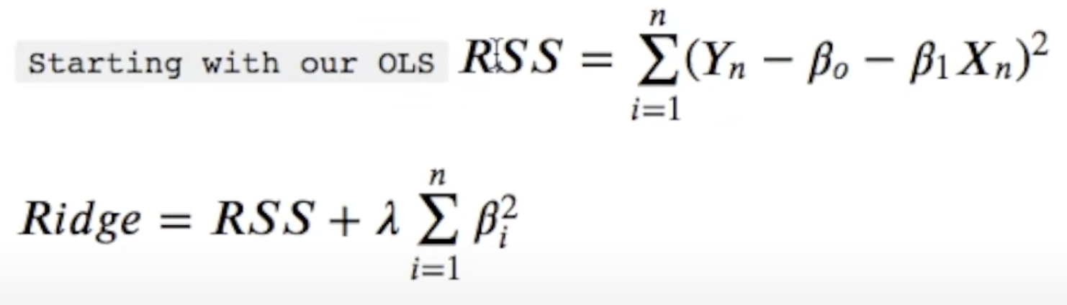

The tuning parameter lambda will be used for regression coefficients:

* When lambda is large, the coefficients β approaches zero 🡪 increase bias and reduce variance (prevent overfitting)
* When lambda is small, will return least squares 🡪 increase variance and reduce bias

Ellipse corresponds to contours of residual sum of squares. The inner ellipse has smaller rss and is minimized by OLS estimates. We are trying to minimize the size of the circle and the ellipse at the same time and we are subject to a constraint 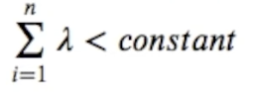. The larger the lambda, the more β’s prefer zero. When lambda = 0, then you have linear regression. The ridge estimate is given when the points at which they touch. To find the optimal lambda, we consider cross validation.

Lasso regression (L1 regularization): The penalty term added to the loss function is proportional to the absolute value of the coefficients

* Lasso regularization shrink some coefficients to exactly zero, effectively **feature selection;** Lasso performs feature selection by setting the coefficients of irrelevant features to 0

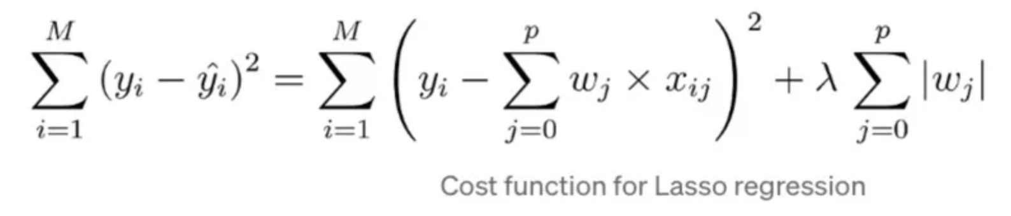

Ridge regression (L2 regularization): The penalty term added to the loss function is proportional to the square of magnitude of the coefficients

* Ridge regularization shrinks the coefficient but not eliminate any. All features remain in the model but influence is reduced

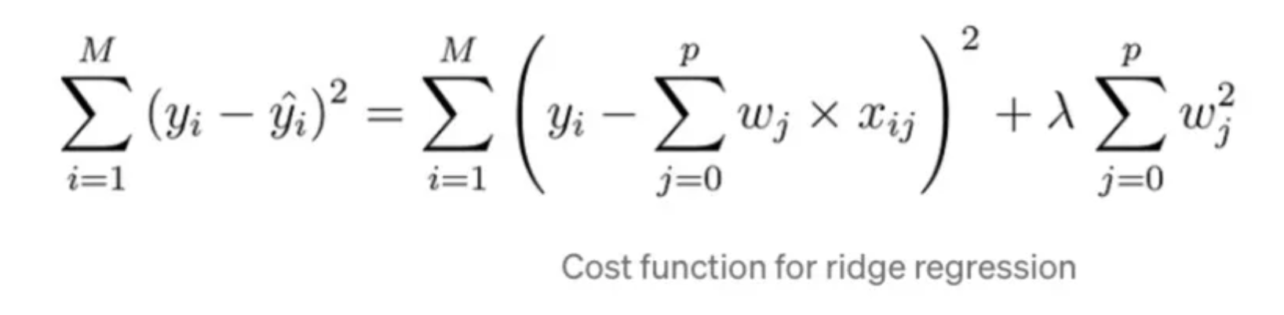

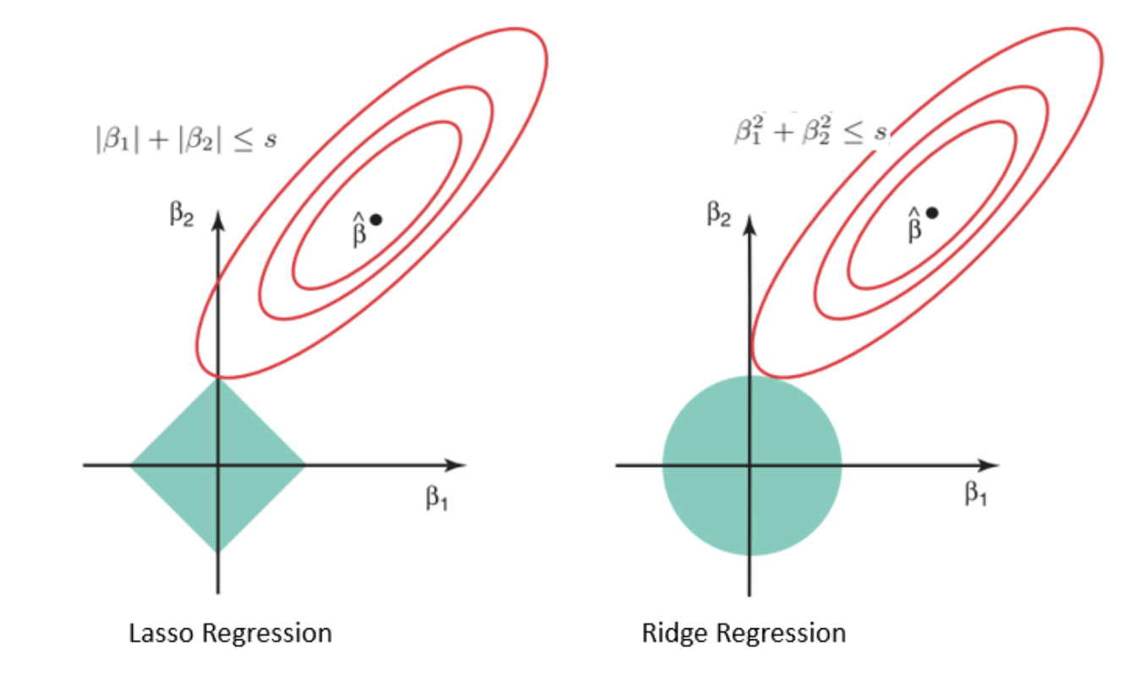

Lasso regression is best when you need sparsity (i.e., to discard irrelevant features), perform automatic feature selection, and simplify your model while focusing on the most important features.

Ridge regression is more suitable when you want to retain all features and when the primary concern is shrinkage to handle multicollinearity or to improve stability in the model.

**Logistic regression**

Loss function for logistic regression?

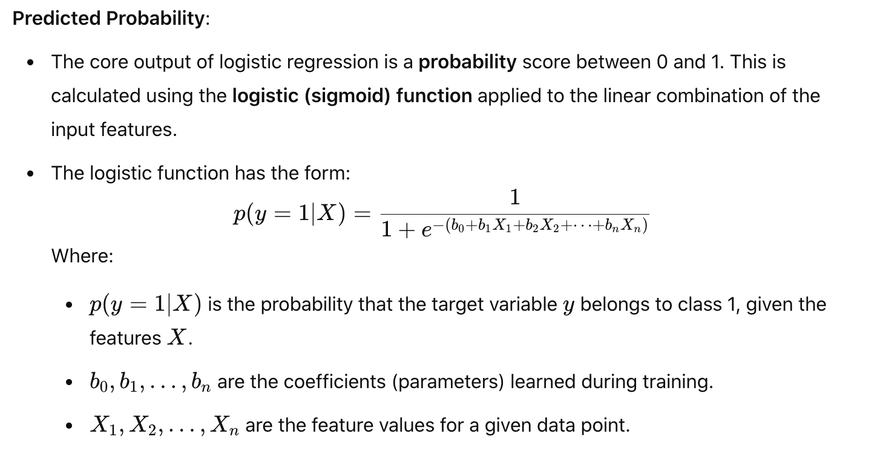

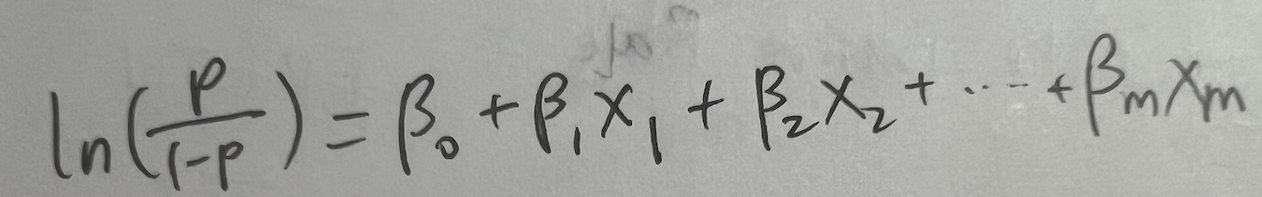

The output of logistic regression is a probability, which represents the likelihood that a given input belongs to a certain class, typically the "positive" class. Typically, logistic regression is used for binary classification, and the decision rule is:

* If the predicted probability is greater than or equal to a threshold (usually 0.5), predict class 1.
* If the predicted probability is less than 0.5, predict class 0.

**Coefficients**

Logistic regression also outputs the **coefficients** for each feature. These coefficients indicate the strength and direction of the relationship between each feature and the predicted probability of the positive class.

* 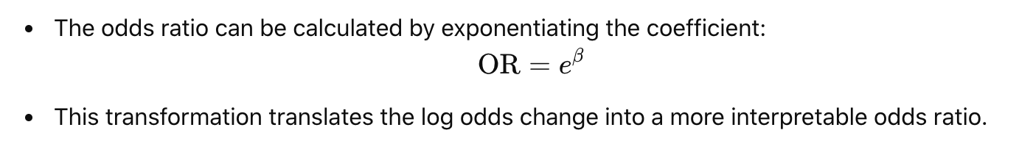

Odds ratio that associates x to y; Ex: smoking group has 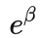times the odds of non-smoking group of having heart disease; the odd for retaining at end of M1 are 163% higher for the users who did Edit action during first 3 days of signup

We want the classifier to minimize the number of misclassified observations: false positive and false negative

|  |  |  |  |  |
| --- | --- | --- | --- | --- |
|  | **1 (predicted)** | **0 (predicted)** |  |  |
| **1 (actual)** | True positive (TP) | False negative (FN)  Type II error | Recall / sensitivity  / True positive rate  TP / (TP + FN) | False negative rate  FN / (TP + FN) |
| **0 (actual)** | False positive (FP)  Type I error | True negative (TN) | Specificity  / True negative rate  TN / (TN + FP) | False positive rate  FP / (TN + FP) |
|  | Precision  TP / (TP + FP) | Negative predictive value  TN / (TN + FN) | Accuracy  (TP + TN)  / (TP + TN + FP + FN) |  |

Trade-off between precision and recall:

* Precision: how many values out of all predicted positive values are actually positive
  + Email spam detection: **precision** is key; In the case of spam filtering, **false positives** (legitimate emails mistakenly classified as spam) are much more problematic than **false negatives** (spam emails that get through the filter).
* Recall: how many positive values out of all positive values are correctly predicted
  + Cancer detection: **recall** is key; In the case of **cancer detection**, **false negatives** (cancer patients who are missed by the model) are far more dangerous and costly than **false positives** (healthy patients who are incorrectly flagged as having cancer).
* Higher recall means we detect more cancer, but may lead to misdiagnose others who didn’t truly have cancer, which is lower precision; Higher precision means more confident that diagnostic comes back positive, the person really has cancer, however, this often means missing some people who truly have disease.

**Logistic regression model evaluation**

* Coefficient: magnitude of the relationship, odds ratio that associate x to y (e^coefficient_x); to answer % increase in x leads to e^coefficient_x-1 % increase in y
* P-value: strong correlation between x and y variables if p-value < 0.05
* **Accuracy and classification metrics**
  + **Accuracy** measures the percentage of correct predictions
  + 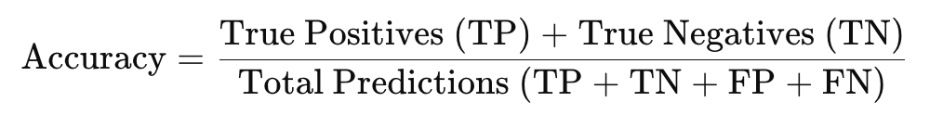
  + **Confusion matrix**
  + **Precision** is the model’s accuracy when predicting positive instances (how many predicted positives are actually positive).

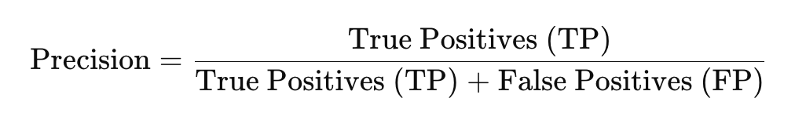

* + **Recall** (or **sensitivity**) is the model’s ability to find all actual positive instances (how many actual positives are correctly predicted as positive).

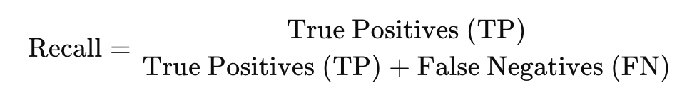

* + The **F1 score** combines these two metrics, making it a balanced measure that reflects both the precision and recall of a model. A high F1 score means that the model has both high precision and high recall, while a low F1 score indicates that either one or both of these metrics are low.
  + 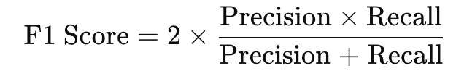
* **Error metrics**
  + False positive rate: how often appropriate content is incorrectly flagged as inappropriate

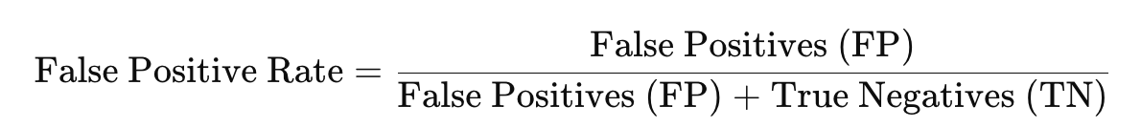

* + False negative rate: how often inappropriate content is missed by the model

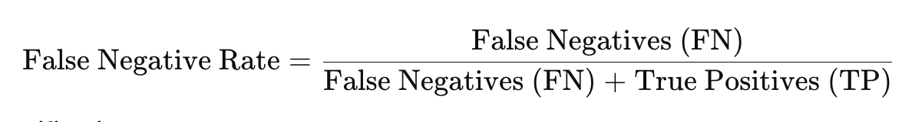

* + Misclassification rate

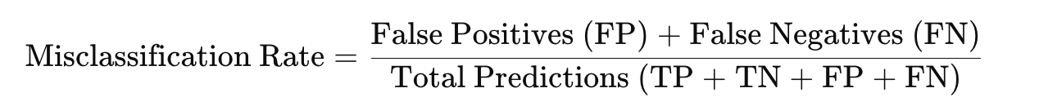

A **receiver operating characteristic** (ROC) curve is a graph that shows how well a binary classifier model performs at different threshold values. It plots the true positive rate (TPR) against the false positive rate (FPR) at each threshold.

AUC measures how well classifier separates classes.

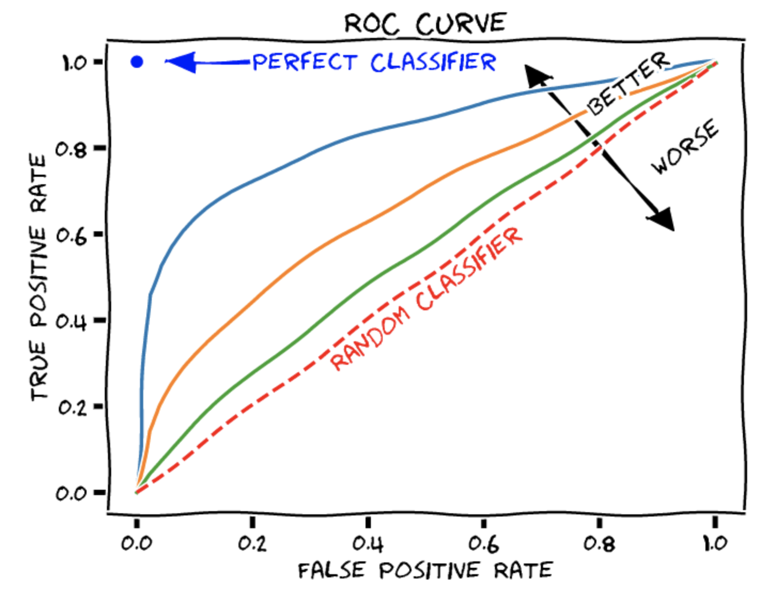

[ROC curve link](https://www.evidentlyai.com/classification-metrics/explain-roc-curve#:~:text=The%20ROC%20curve%20stands%20for,False%20Positive%20rates%20(FPR).)

As you try to increase the TPR (i.e., correctly identify more positive cases), the FPR may also increase (i.e., you get more false alarms).

Threshold higher:

* More positive prediction
* Lower recall / true positive rate
* Increase precision
* Lower false positive rate

Threshold lower:

* Fewer positive prediction
* Increase recall / true positive rate
* Lower precision
* Higher false positive rate

AUC is between 0 and 1

As a rule of thumb, a ROC AUC score above 0.8 is considered good, while a score above 0.9 is considered great.

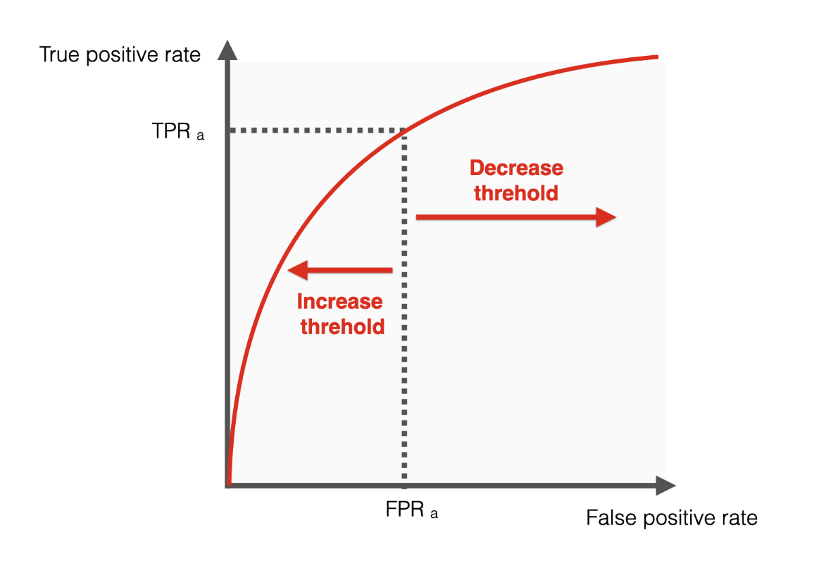 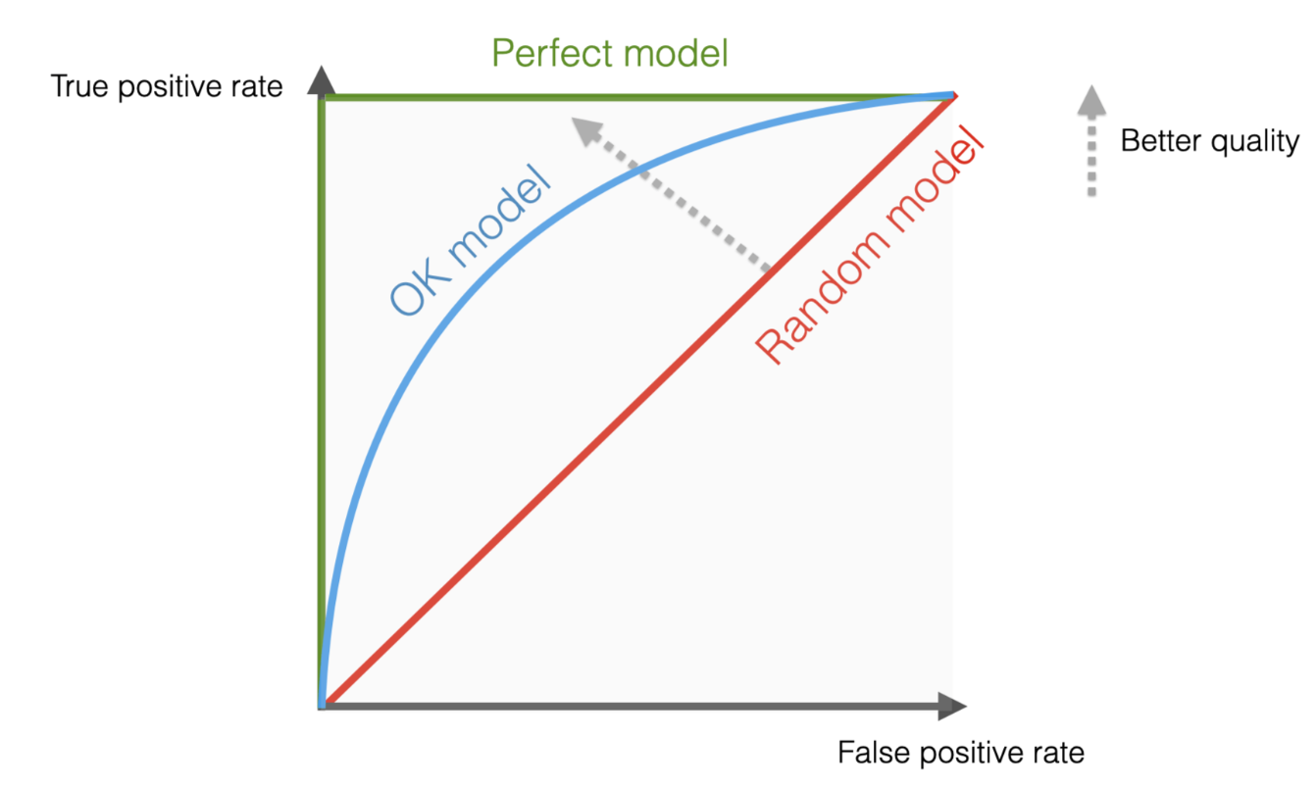

You could optmize precision at recall 0.95: constrain recall to be at least 0.95 while optimizing for precision. Or suggest blending multiple metrics into one by weighting different sub-metrics, such as false positive vs. false negatives.

**Weaker learners: KNN – K nearest neighbors**

* supervised learning algorithm for both classification and **regression** tasks

Steps for KNN:

1. Choose the value of K: First, you need to choose a value for K, which represents the **number of nearest neighbors** to consider when making a prediction. This value is typically odd for classification tasks to avoid ties (e.g., K=3, K=5). For regression tasks, K can be any positive integer.
2. Calculate the distance between data points: To find the nearest neighbors, KNN uses a distance metric to measure how similar or dissimilar two data points are. The most common distance metric is **Euclidean distance**, but other distance measures like **Manhattan** or **Cosine similarity** can also be used, depending on the application.

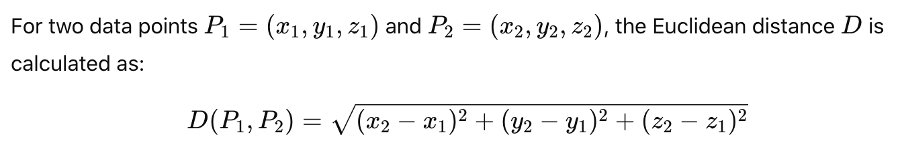

1. Find the K-nearest neighbors: Once the distance is calculated, KNN identifies the **K** closest data points to the target data point (the point for which we want to make a prediction).
2. Make the prediction:
   * **Classification**: In classification, KNN assigns the most frequent class label among the **K nearest neighbors** to the target data point.
   * **Regression**: In regression, KNN calculates the **average** (or sometimes the weighted average) of the target values of the K nearest neighbors and assigns this value as the prediction.

Overview

* Classification: same value as the point’s k closest neighbors
* Regression: average value as the point’s k closest neighbors
* Get a new input -> calculate the distance of its k closest pair -> use relevant majority vote (or averages) to predict

**Random Forest**

* Bagging algorithm (Bootstrap-Aggregation)
  + “average” the output of trees: multiple decision trees are built and then combined to improve performance
    - Random Forest creates a large number of decision trees.
    - Each tree is trained on a random subset of data (with replacement) and at each split, a random subset of features is considered.
    - The predictions of all the trees are combined (usually by voting for classification or averaging for regression) to make the final prediction.
  + Ensemble learning method used for both classification and regression.
  + Small variance, but more bias; less likely to overfit, potentially more likely to underfit
* Parameters:
  + Max_depth: max depth of each tree
  + Min_sample_split: minimum sample needed to split a node
  + Max_features: maximum number of features looking at to split
  + Num_trees doesn’t matter that much as long as we reach a certain level, since we are doing average at the end

**How does Random Forest Work?**

Random Forest is built on the idea of **bagging** and **random feature selection**. Here's a step-by-step explanation of how a random forest is constructed:

* Bootstrap Sampling (Bagging):
  + Random Forest uses **bootstrapping** to create multiple subsets of the training data by randomly sampling from the original dataset **with replacement**. This means some data points might appear more than once in the sample, while others might not appear at all.
  + Each decision tree in the forest is trained on a different subset of data (with replacement), making the trees diverse.
* Building Decision Trees:
  + A decision tree is grown for each bootstrap sample. For each decision tree:
    - At each node, instead of considering all features, a random subset of features is selected (feature bagging).
    - The best feature among this random subset is used to split the data at each node.
    - This introduces diversity into the trees, reducing correlation between them, which in turn improves the ensemble’s performance.
* Prediction by Aggregation:
  + Once all the trees are built, predictions are made:
    - For Classification: Each tree "votes" on the class, and the class with the majority of votes is the final prediction (majority voting).
    - For Regression: The final prediction is the average of the predictions made by each tree.
* Out-of-Bag (OOB) Error:
  + For each tree, there are certain observations that are not selected in the bootstrap sample (since the sample is drawn with replacement). These observations are called out-of-bag observations.
  + The OOB samples are used to estimate the model's generalization error, which can be used as a **cross-validation** method for assessing the performance of the random forest without needing a separate validation set.

**Advantages of Random Forest**

1. High Accuracy:
   * Random Forest typically provides **high accuracy** because it reduces overfitting by averaging multiple decision trees. Each individual tree might overfit on the data, but the ensemble model mitigates this risk.
2. **Robust to Overfitting:**
   * By averaging the predictions of many trees, random forest **reduces the variance and prevents overfitting**, which is common in decision trees.
3. **Handles High Dimensionality:**
   * Random Forest can handle a large number of input features, even when there are complex interactions between them.
4. **Feature Importance:**
   * Random Forest can be used to determine the **importance of each feature** in predicting the target. This is useful for feature selection and understanding the relationship between variables.
5. **Handles Missing Data:**
   * Random Forest can handle missing values by using the available data in each tree, making it robust when dealing with incomplete datasets.
6. **Non-linear Relationships:**
   * Random Forest can model complex, **non-linear relationships** between the features and the target variable.
7. **Versatility:**
   * Random Forest can be used for both **classification** (predicting categorical labels) and **regression** (predicting continuous values).
8. **Out-of-Bag Error Estimation:**
   * It can provide an unbiased estimate of the model’s performance on unseen data through **out-of-bag** error, without the need for a separate validation set.

**Disadvantages of Random Forest**

1. **Complexity:**
   * Random Forest models can be computationally expensive to train and predict, especially when the number of trees is large.
   * The model can also become large and slow to predict, especially for **real-time applications** or **deployments** requiring fast inference.
2. **Lack of Interpretability:**
   * Unlike a single decision tree, which can be visualized and interpreted, Random Forest is more of a **black-box model**. It’s harder to explain how the model makes specific predictions because it combines many trees.
3. **Memory Intensive:**
   * Since it builds many decision trees and stores them in memory, Random Forest models can be memory-intensive, particularly when dealing with large datasets or large forests.
4. **Risk of Overfitting with Too Many Trees:**
   * Although Random Forests tend to reduce overfitting, having an **excessively large number of trees** can lead to overfitting or increase training time unnecessarily.

**Key Parameters in Random Forest**

1. **n_estimators:**
   * The number of trees in the forest. More trees generally improve the performance of the model, but also increase computational cost.
2. **max_depth:**
   * The maximum depth of each decision tree. Increasing the depth allows the model to capture more complex relationships but can lead to overfitting.
3. **min_samples_split:**
   * The minimum number of samples required to split an internal node. A higher value can help prevent the tree from growing too deep and overfitting.
4. **min_samples_leaf:**
   * The minimum number of samples required to be at a leaf node. This can help to smooth the model and reduce overfitting.
5. **max_features:**
   * The number of features to consider when looking for the best split. Using fewer features can reduce overfitting but might increase bias.
6. **bootstrap:**
   * Whether bootstrap sampling is used when building trees. This is typically set to True for Random Forest.
7. **oob_score:**
   * Whether to use **out-of-bag samples** to estimate the generalization error. If set to True, this will enable out-of-bag error estimation.

**Comparing random forest and decision trees**

* Decision trees:
  + Decision trees build a single tree using the data and try to split it in the best way to predict the target variable
  + Prone to overfitting, especially with complex or noisy data.
* Random Forest:
  + Random Forest aggregates predictions from many decision trees, which reduces overfitting and variance.
  + It also uses random features selection at each split, making the model more robust and better at generalizing to new data.

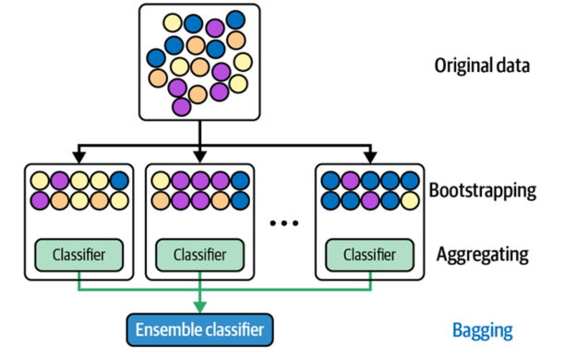

**Comparing random forest and regression**

Random forests offer several advantages over traditional regression, particularly when dealing with complex datasets with high dimensionality, non-linearity, and interactions between variables. Here are some key benefits of using random forests for regression tasks:

* Handles **Non-Linearity** and Interactions: Unlike linear regression, which assumes a linear relationship between predictors and the target variable, random forests can model complex, non-linear relationships and interactions among features without requiring explicit specification.
* **Reduces Overfitting**: Random forests combine multiple decision trees, each trained on a subset of the data, and then aggregate their predictions. This process helps reduce overfitting by balancing individual trees' variance, providing a more robust and generalizable model.
* **Feature Importance**: Random forests provide a measure of feature importance, which indicates the most influential predictors in the model. This can be useful for feature selection and understanding which variables contribute most to predictions.
* Handles High-Dimensional and Sparse Data: Random forests work well with large datasets, especially those with many features, because they handle high-dimensional spaces efficiently. They are also effective with sparse data and can often handle missing values without complex imputation techniques.
* Robustness to Noise and Outliers: Since random forests use an ensemble of trees, they are less sensitive to outliers and noise in the data. Outliers may affect individual trees, but their effect is diluted when averaged over the entire forest.
* Minimal Data Preprocessing: Unlike linear regression, random forests don’t require strict assumptions about the distribution of the predictors. They don’t need scaling or transformation of features and can work well with both categorical and numerical data (with some adjustments for categorical features).
* Parallelization: Random forests can be easily parallelized because each tree is built independently. This makes them computationally efficient for large datasets when resources allow for parallel processing.
* Versatility: Random forests can handle both regression and classification tasks, making them a flexible choice for many types of machine learning problems.

**Boosting**

* Boosting: stack on models
  + Model 1 fit; model 2 fit on error of model 1; model 3 fit on error of model 2 etc…
  + Then add up predictions
* Big variance, less bias, more likely to overfit
* Parameters:
  1. Max_depth
  2. Learning Rate (if it is smaller, it penalizes more for subsequent models, therefore we need more models to converge)
* Trains a sequence of weak models (i.e. small decision tree) where each one sequentially compensates for the weakness of the preceding models.
  + Weakness can be measured by current model’s error rate and the relative error rates can be used to weigh which observations the next models should focus on
  + Each training point within a dataset is assigned a particular weight and is continually re-weighted in an iterative fashion such that points that are mispredicted take on higher weights in each iteration
* **AdaBoost**:
  + **Weak Learners:** AdaBoost typically uses decision trees with just a single split (called "stumps") as weak learners. These weak learners perform slightly better than random guessing.
  + **Sequential Learning:** AdaBoost works by training weak learners sequentially. Each new learner focuses on the examples that were misclassified by the previous ones. In other words, it gives more weight to the instances that are harder to classify correctly.
  + **Weight Adjustment:** Initially, all training examples have equal weight. After each weak learner is trained, the weights of misclassified instances are increased so that the next learner pays more attention to these difficult cases. Correctly classified instances have their weights reduced.
  + **Final Model:** After all weak learners are trained, AdaBoost combines them into a weighted sum (or weighted majority vote for classification) to produce a final prediction. The predictions of each learner are weighted by how well they performed during training.
* **XGBoost**: Gradient boosting is similar to AdaBoost, except that shortcomings of previous models are identified by gradient rather than high weight points, and all classifiers have equal weights instead of having different weights
  + **Gradient Boosting**: XGBoost is based on gradient boosting, which is an iterative process where new models (typically decision trees) are trained to correct the errors made by previous models. It focuses on minimizing the loss function using gradient descent.
  + **Speed and Efficiency**: XGBoost is known for its speed, which comes from the use of efficient algorithms and optimizations (e.g., parallelization, handling missing values internally). It also leverages techniques like **tree pruning**, which allows the algorithm to make faster predictions and be more efficient during training.
  + **Regularization**: XGBoost has built-in support for **regularization** (both L1 and L2), which helps reduce overfitting. Regularization is a technique used to prevent the model from becoming too complex and thus overfitting the training data.
  + **Handling Missing Data**: XGBoost is capable of handling missing values directly during training, which makes it very convenient when dealing with real-world data that might have missing entries.
  + **Feature Importance**: XGBoost can provide **feature importance** scores, which helps in understanding how the model is making decisions. This is valuable for interpreting the model, especially in complex datasets.
  + **Parallelization**: XGBoost supports parallelization of tasks like tree construction, which makes it very fast, especially when working with large datasets.
  + **Cross-validation**: XGBoost includes a **cross-validation** method, which helps in tuning the model parameters more efficiently.

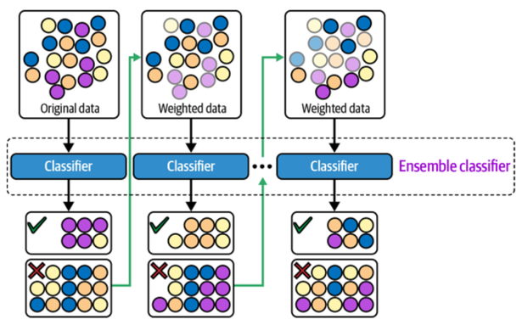

**Comparing random forest and boosting**

### K-means clustering

K-means clustering is a popular unsupervised machine learning algorithm used to group a set of data points into k clusters, where each data point belongs to the cluster with the nearest mean (or centroid).

Here’s a simple breakdown of how it works:

* Choose the number of clusters (k): You need to decide how many clusters you want to divide your data into.
* Initialize centroids: Randomly select k points from the dataset as the initial centroids (the center of each cluster).
* Assign points to clusters: Each data point is assigned to the nearest centroid based on a distance metric, usually Euclidean distance. This means every point will belong to the cluster whose centroid is closest.
* Recalculate centroids: Once all points are assigned to clusters, the centroid of each cluster is recalculated as the mean of all the points within that cluster.
* Repeat steps 3 and 4: The algorithm keeps reassigning points to the nearest centroids and recalculating the centroids until the assignments no longer change, or a predefined number of iterations is reached. At this point, the clusters are stable.

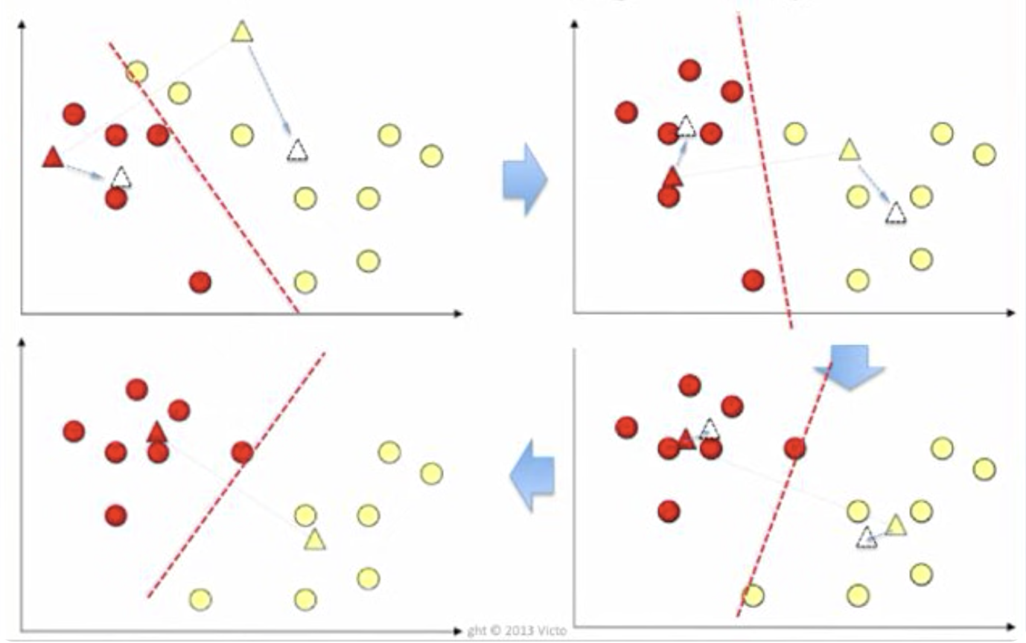

**How to choose the k for k-means clustering?**

1. **The Elbow Method**

The Elbow Method is one of the most popular techniques for selecting *k*. Here's how it works:

* Run the K-means algorithm for a range of *k* values (e.g., from 1 to 10).
* For each value of *k*, calculate the Within-Cluster Sum of Squares (WCSS), which measures how compact the clusters are. WCSS is the sum of squared distances between each data point and its cluster centroid.
* Plot a graph of *k* (on the x-axis) vs. WCSS (on the y-axis).

What you’re looking for is the "elbow" point in the graph—where the rate of decrease in WCSS starts to slow down. The idea is that increasing *k* beyond this point doesn’t significantly improve the clustering, and you’re getting diminishing returns on the compactness of the clusters.

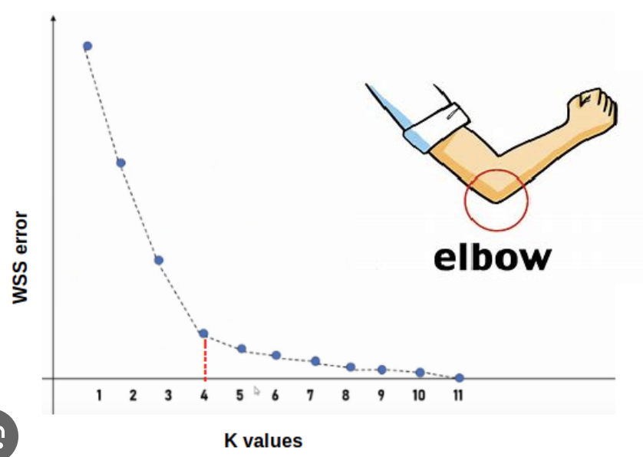

Example**:** Let’s say you try *k* values from 1 to 10. If you plot the WCSS for each *k*, you might see a sharp drop in WCSS up to *k = 3*, and then the curve flattens out. In this case, *k = 3* might be the ideal choice.

2. **The Silhouette Method**

The Silhouette Method measures how similar each point is to its own cluster (cohesion) compared to other clusters (separation). It provides a way to evaluate the quality of clustering.

* For each data point, calculate its silhouette score, which is a value between -1 and 1.
  + A score close to **+1** means the point is well-clustered (far from other clusters).
  + A score close to **0** means the point is on or very close to the boundary between two clusters.
  + A score close to **-1** means the point is likely misclassified.
* Average the silhouette scores for all points for each value of *k*.
* Choose the *k* that maximizes the average silhouette score. A higher score indicates better-defined clusters.

The Silhouette score for a data point iii is calculated using the following formula:

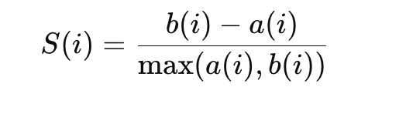

Where:

* a(i) is the average distance from the point iii to all other points in the same cluster (this measures how cohesive the cluster is for that point).

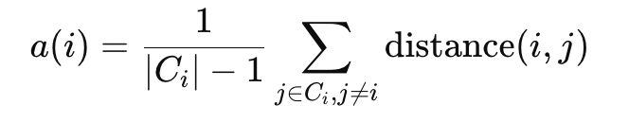

* b(i) is the average distance from the point iii to all points in the nearest cluster (this measures how well-separated the cluster is from other clusters).

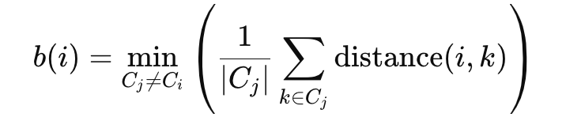

To get an overall measure of clustering quality, calculate the average silhouette score for all data points:

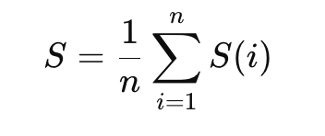

**Comparison on models**

|  |  |  |
| --- | --- | --- |
| **Model** | **Pros** | **Cons** |
| Regression | - Simple and easy to understand  - Interpretability: easily understand how features affect the target variable  - Fast training time  - Good for linearly correlated data | - Assumption of linearity: not perform well on non-linear data  - High bias  - Sensitive to outliers  - Multicollinearity: not work for highly correlated independent variables |
| Decision trees | - Easy to interpret  - Non-linear relationships  - No need for feature scaling: not require normalization or standardization of features | - Tend to overfit, large variance  - Bias towards feature with more levels: favor features with many distinct values |
| Random forest | - Robust and prevent overfitting, lower variance vs. decision tree  - Good with large datasets  - Work with both regression and classification tasks  - Feature importance | - Less interpretability: vs. decision tree  - Computationally expensive  - Slower prediction time |
| Boosting | - High accuracy: reduce bias and variance  - Works well with weak learners  - Handles complex data patterns  - Robust to overfitting with regularization | - Computationally expensive vs simple models  - Hard to interpret  - Sensitive to noisy data: can overfit noisy data if not carefully tuned  - Without regularization, boosting can overfit |
| K-means | - Simple and efficient  - Scalability: scales well with large datasets  - Works well with well separated clusters  - Unsupervised | - Need to specify k  - Sensitive to initial centroid: sensitive to initial placement of centroids  - Assumes spherical clusters  - Not suitable for clusters of varying sizes and densities |

**Cross validation**:

* a technique used to assess the performance of a machine learning model
* In essence, cross-validation allows us to estimate the model's accuracy by testing it on different subsets of the data.

Types of Cross-Validation:

1. K-Fold Cross-Validation (Most Common)

In K-fold cross-validation, the dataset is divided into K equally-sized "folds". For each fold:

* The model is trained on the K-1 folds (the training set).
* The model is tested on the 1 remaining fold (the test set).

This process is repeated K times, each time using a different fold as the test set. The final model performance is averaged over all K iterations.

Steps for K-Fold Cross-Validation:

* Split the dataset into K subsets (folds).
* For each fold:
  + Use K-1 folds for training the model.
  + Test the model on the remaining fold.
* Average the performance metrics (e.g., accuracy, F1 score) across all folds to get the final performance.

2.Leave-One-Out Cross-Validation (LOO-CV)

Leave-one-out cross-validation (LOO-CV) is an extreme case of K-fold cross-validation where K equals the total number of data points. That is, for each iteration, a single data point is left out as the test set, and the model is trained on all other points.

Why Use Cross-Validation?

* **Prevents Overfitting**: Cross-validation helps to detect overfitting, where the model performs well on the training data but fails to generalize to unseen data. By testing on different subsets of the data, cross-validation helps you better estimate how the model will perform on new data.
* **Better Estimate of Model Performance**: Using different subsets for training and testing provides a more reliable performance estimate than just using a single training/test split.
* Utilizes All Data for Training and Testing: In methods like K-fold, every data point gets used for both training and testing, which means the model has the opportunity to learn from all of the data.
* Better for Small Datasets: If you have a small dataset, using K-fold or LOO cross-validation can be especially valuable because it maximizes the amount of data used for both training and testing.

**Cross validation for time series data**:

* You should not use data in the future for predicting data from the past.
* The model should always be trained on past data and tested on future data

TimeSeriesSplit (Rolling or walk-forward validation):

* TimeSeriesSplit is a method provided by libraries like Scikit-learn. It works by splitting the data into multiple training and testing sets while respecting the temporal order. Each split includes a larger portion of the data for training, and the test set moves forward in time.
* In each fold, the model is trained on a growing dataset and tested on a fixed window of data that occurs after the training set.
* For example, suppose you have a dataset with time points 1 through 10. In the first fold, the model could be trained on data points 1-5 and tested on data point 6. In the second fold, it could be trained on data points 1-6 and tested on data point 7, and so on.

**How to prevent overfitting?**

* Use more data: More training data allows the model to learn more general patterns and reduces the chance of fitting to noise. If it's not possible to collect more data, you can try data augmentation techniques (for example, in image or text data) that artificially expand your dataset
* Cross validation: Use techniques like **k-fold cross-validation** to estimate how the model will perform on unseen data.
* Regularziation: Regularization adds a penalty to the model's complexity, discouraging overly complex models that fit the noise in the data.
* Pruning (for decision trees and random forest): Pruning involves cutting back the size of decision trees after they are grown, reducing their depth and complexity to prevent them from learning overly specific details in the training data.
* Ensemble methods: Ensemble learning methods combine predictions from multiple models to improve generalization.
  + Bagging (e.g., Random Forests): Combines predictions from multiple decision trees trained on different subsets of the data. It helps reduce variance and prevents overfitting.
  + Boosting (e.g., XGBoost, AdaBoost, LightGBM): Sequentially trains models, focusing on the errors made by previous models. Boosting reduces bias and variance but needs careful tuning to prevent overfitting.
  + Stacking: Combines predictions from multiple models using a meta-model. This often reduces overfitting compared to a single model.
* Feature selection: Removing irrelevant or highly correlated features reduces the chance that the model will fit to noise.

**Hyperparameter tuning**

* Grid search: form a grid that is the product of those parameters, then trying all such combinations and seeing which yields the best results
* Random search: define a distribution for each parameter and randomly sample from the joint distrubution over all parameters.

**Training times and learning curves**

* X-axis: experience (time); y-axis: metric of learning
* How would you identify if your model is overfitting? As number of iterations is increasing, the training error is getting better. However, the validation error is not improving but increasing – a clear sign that model is overfitting and raining can be stopped

**Feature engineering**

FB modeling features:

* Demographics / profile: country, region, city, gender, age, language, interest / hobby, tenure (new vs. existing), lifestyle
* Behavioral:
  + time spent, views, clicks, likes, shares, comments, purchases, visits
  + pages liked, events joined, groups joined, posts shared, content searched and followed
  + ratings, reviews
* Social interaction with friends:
  + Posts mentioning friends
  + Likes and shares friend’s posts
  + Message with friends
  + Photo tags with friends
* Contextual data:
  + time of day, day of week, events or special occation
* New feature / functionality: binary 1/0
* Device: android vs ios vs desktop
* Platform: web vs. mobile vs. mobile web
* Marketing channel: paid vs. non paid

Doordash modeling features:

Doordash – which new restaurants should we add to our merchant list?

Success of new merchant? (first few months)

* Numbers of orders per month from merchant * (Get repeat customers, new customers and new merchants (network effect) into DD)
* Revenue from this merchant
* User 1+ like, 1+ share or 2+ comment on the restaurant
* Customer satisfaction: customer rating – guardrail

Model features:

* User:
  + Demographics: region, region, city, gender, income, age, occupation, lifestyle
  + Behavioral: Time spent on app, like, click, orders
* Item - merchants:
  + Attributes of merchants: cuisine type, pricing, location, business hours, menu, size, yelp rating, google reviews
* Interaction:
  + User 🡪 restaurant: likes/shares on restaurant page
  + Restaurant 🡪 user
* Contextual: location, population density, distance to high intensity residual area (measure of demand), competition of the area

*Notes:*

* Correlation with long term outcome
* Start with daily or weekly average orders (speed of decision making is also critical)
* Ground truth is from historical data